**CIS-310 SUMMER 21 NOTES – DEMETRIUS JOHNSON**

# CIS 310 – SUMMER I – with David Yoon

# Lecture 1 notes

* In order to communicate with hardware, we need levels of software, that can eventually communicate with us so that we can control hardware
* Hardware only understand 1 thing: switch is on, or switch is off
* A computer system consists of three main components
  + Users
  + System software
  + Hardware
* The operating system is a resource manager: manages memory, CPU, etc..the hardware..
* Number systems
  + Users use decimal
  + CPU use Hexidecimal
    - CPU grabs 4 bits at a time
  + Memory is stored in Binary
* Remember for computer languages, everything has to at some point break down to a number; that’s why we have the ASCII table
* ASCII uses only 7 bits, the 1st bit is not used out of the 1 byte (8 bits)
  + Of course ASII has 2^7 possible values: so there are 128 characters on the ASCII
* Writing a number N with base b 🡪 (N)b:
  + 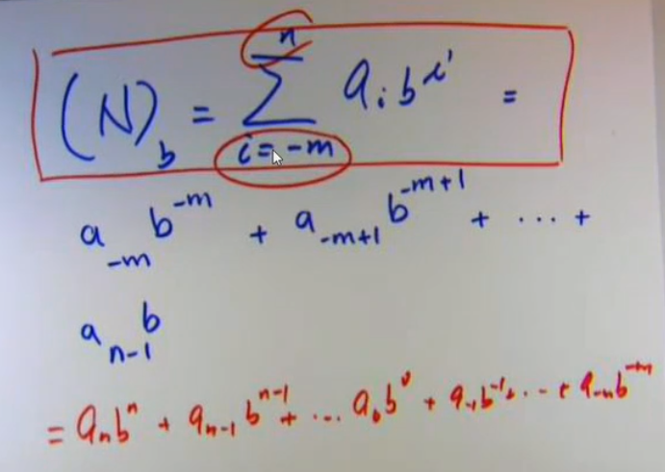
  + The correct polynomial representation of the summation is in red
  + 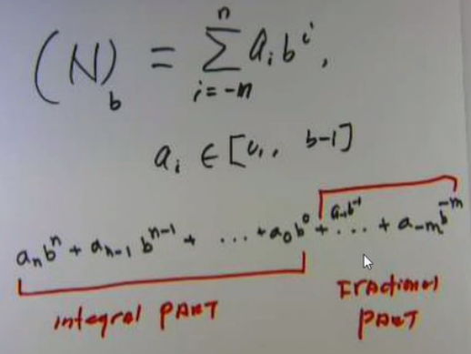
  + Remember: a real number consists of an integral part, and a fractional part
  + n is leading term, so he started expanding the sum from the leading term and worked down to the minimum term
* 4 bits = 1 nibble
* For integral (whole number) part of a decimal, to convert it to a new base, DIVIDE by the base and repeat; the remainder each time is the next place value for the new-base number; keep doing this until the number is reduced to 0.
  + To convert fractional part of a decimal number to a new base, MULTIPLY by the base; the whole number portion of the result is the place value for each decimal digit of the new base; keep doing this until you get a whole number and no remaining fraction.
* To convert from any other number base to decimal base, simply write out the number in polynomial form according to its base and add up the results to get the decimal equivalent
* SMR: Signed Magnitude Rep. (uses 8 bits to represent a range of pos. and neg. integers)
  + First bit is the sign bit
  + Remaining 7 bits rep. the numerical value
  + SMR is an older-style rep. for integers that is more difficult for computer systems to do arithmetic operations, so today we have other rep. methods that are better and faster for computer architectures

# Lecture 2 notes

* -m = # of fractional digits
* n= # of whole digits
* **B’s compliment:**
* note: the compliment of a number is simply the value that has to be added to it in order to get to the next place (higher power); for example; 10’s compliment of 9 = 1; also, 10’s compliment of 10 = 90
* 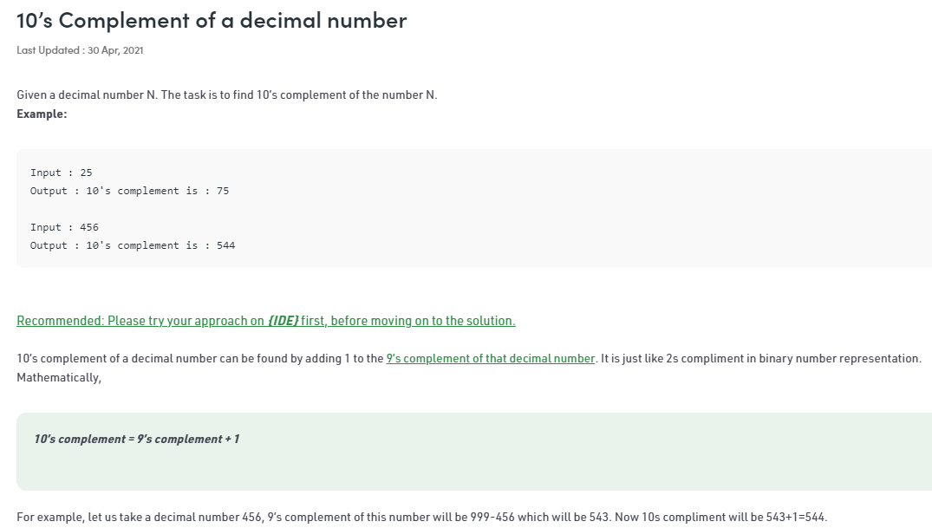
* Also, here is the formula for any base: 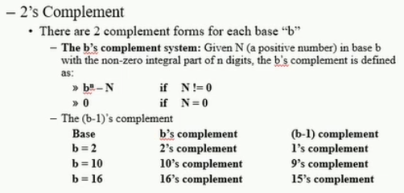
* For decimal values, its very easy, simply take the first place vale (0 power) and subtract the decimal value from that 0-power place value:
* 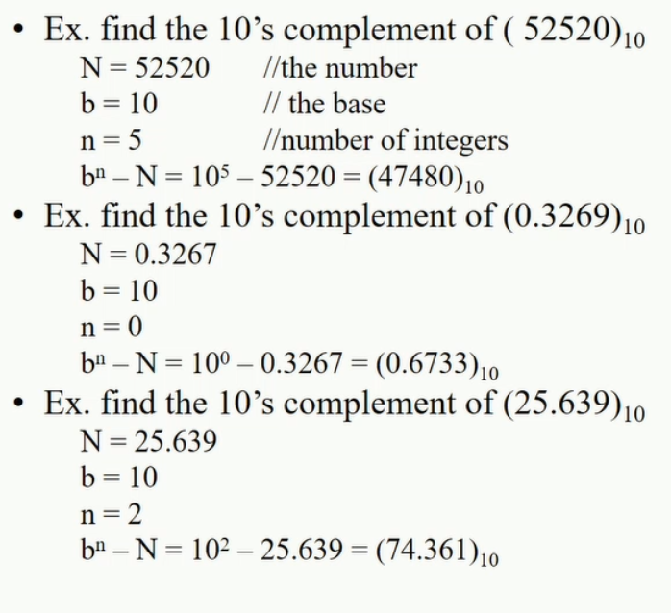
* Special Note: Since binary is base 2 and only has digits 0 and 1, then you can do a special thing when finding the compliment because of what happens when you have to borrow: simply switch all 0’s to 1’s and 1’s to 0, and add 1; we add 1 because it will be the remainder digit that will be left over after you borrow from the highest power and channel it down until you borrow from the 0-power when doing the subtraction….so that additional value from the 0’s power can simply be added at the end to get the final solution
* **B-1’s compliment:**
* 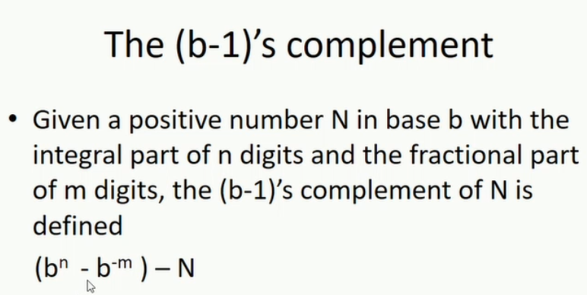
* 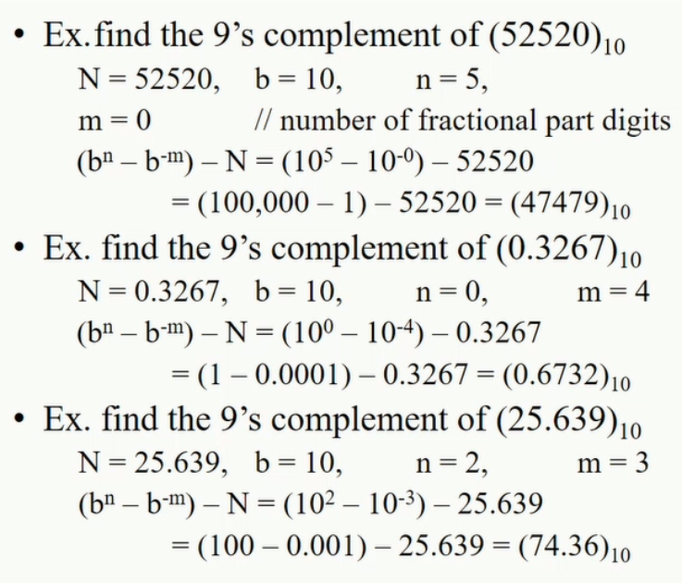
* 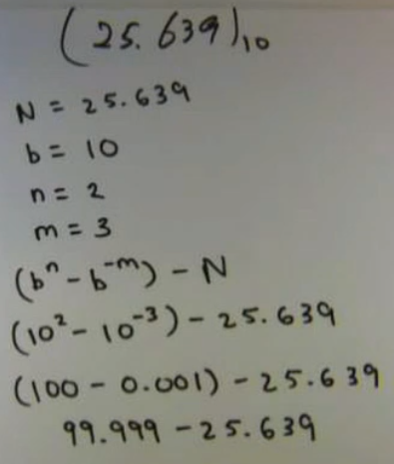
* So b-1’s compliment of a number is the number that you must add to it in order to get a value that is just below the next higher power place value of the number; the precision of “just below” depends on the number of decimal places in the number, and it refers to that lowest place value and all subsequent higher place values being 1 digit short of carrying over to the next place value; or in other words, **b-1’s compliment is the number you must add to a number that would result in all place value digits of the number being at their maximum digit. So 9’s compliment of 25 == 99 – 25 = 74; note how 99 is just 1 short of the next place value power (100); the 9’s compliment of 88.8 == 99.9 – 88.8 = 11.1. same here, all place values are at their max digits if you add 88.8 + 11.1 = 99.9.**
* To find b’s compliment, you could simply find b-1’s compliment and add 1 to the lowest place value; or to find b-1’s compliment, you could find b’s compliment and subtract 1 from the lowest place value; remember: the reason this works is simple! It is because of what happens when you subtract the next higher power from a number that is 1 power lower; you will end up borrowing values all the way down to the lowest place value (including decimals), and since binary only has 2 digits (0 and 1), then we can take advantage of this fact to use this trick for finding compliments (and doing addition and subtraction); computers take advantage of this base-2 feature as well to make calculations fast and efficient for both addition and subtraction (by using only addition and compliments; and of course computers use the binary number system).
* For binary since there are only 2 digits, then to find 2’s compliment you flip 0’s and 1’s and add 1; but to find 1’s compliment of a binary value simply just flip 0’s and 1’s and do NOT add 1; and of course to change into 2’s compliment then add 1; this is useful especially for high speed computer processing that makes it easier to add and subtract by only using addition principles and using compliments; no need for a separate subtraction unit for a computer architecture.
* So, with machine representation of integers; when the sign bit is negative, use 2’s compliment!:
* 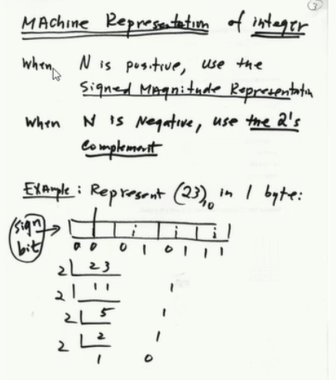
* Notice: if a number is negative, then doing 2’s compliment will of course change the highest place value to a 1; and we know that 1 in 1’st bit of the 8-bit SMR number means that the number is negative; but you don’t simply change it to 1; you take the 2’s compliment of the negative value, and this is how it is represented in machine language. So SMR of +23 = 00010111; but -23 is represented by 2’s compliment of +23: 11101000 + 1 = 11101001 (I took 1’s compliment and added 1 to get 2’s compliment); and now notice how still the sign bit is 1 = a negative number

# Lecture 3 notes - IEEE Floating Point Format

* To verify a negative number is correctly represented by 2’s compliment, simply take the 2’s compliment of the result and you should get the positive version of the negative value
* Remember too a special thing for using b’s compliment and making subtraction easier, you can always borrow from the next place value, even if it is 0..in theory you can infinitely borrow from the higher powers place values; as long as those values are accounted for; for machine representation and handling of subtraction, it will borrow from the next place value and handle it (which is why we add 1 at the end as the borrow funnels down to the lowest place value eventually) even if the next higher power = 0; and also it can ignore the higher powers that it borrows from as long as it gets the correct answer for an addition or subtraction; it ties in a way to another idea called overflow
  + The idea of carrying past the known place values (say 8 bits in a char) is called overflow!
  + 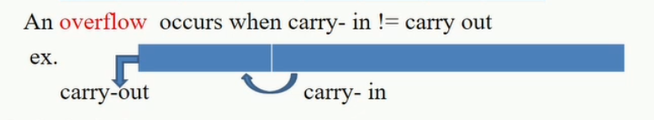
  + So for example, when you add int in 1 byte + another 1 byte int, the result is still represented as 1 byte; so if the addition is too large there may be overflow
  + Carry out bits are stored in a special bit called carry bit (c[])
  + 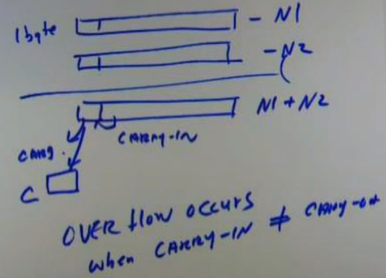
  + If carry-in == carry-out, then we can ignore what was carried out and even though there is overflow, the overflow does not affect arriving at the correct conclusion as long as you ignore the overflow; so we say “no overflow exists”; if carry-in != carry-out, we cannot simply ignore the overflow of bits and thus we say “overflow exists” which means correct answer was not acquired by the representation with a specified set of bits; we say overflow when carry-in != carry-out also because overflow will happen with the sign bit being overflowed, or the value will be too large for the number of bits used to represent a number and so a carry-out bit will end up going to a power that’s even past the signed bit. So if sign bit is overflowed, or overflow occurs past that, it is called overflow and thus the answer will not be correct for some arithmetic.
  + Below is an example using 4 bit integers, with the 1st bit being used as the sign bit, and we represent numbers using SMR and 2’s compliment (for negative values):
  + 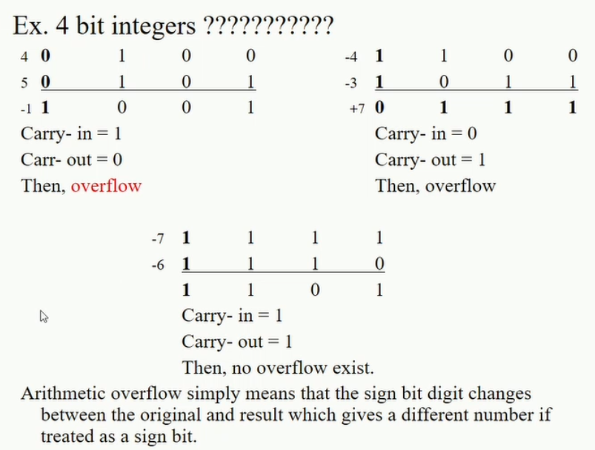
* **Machine representation of Float Point Numbers**
* A floating point number is represented as:
* 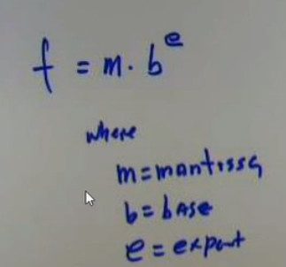
* For float point numbers, it was good to avoid having to have 2 signed bits (one for the mantissa, and one for the exponent), so we use what we call a Biased Exponent
* 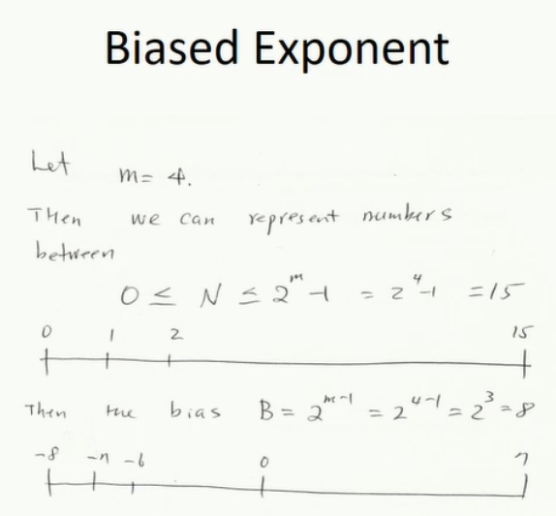
  + Where m in this case = number of bits
  + To represent both +/- numbers, we shift range by B; the bias.
  + So 15 – 8 = 7; 0 – 8 = -8; thus new range is [-8, 7]
* IEEE Floating Point Format
  + Represents float point numbers using 32 bits: 1 sign bit, 8 bits for exponent, 23 bits for fractional part (mantissa)
  + Exponent is biased at 127: B + actual exponent, where B (the bias) = 127; so E = B + E 🡪 127 + E
  + Fractional part is greater than or = 1, but less than 2
  + To convert a number into IEEE FP, simply convert it to binary, then set sign bit accordingly, and then put binary number F portion into the form 1.F so that you can acquire the exponent, then set exponent (8 bits) according to the bias by doing actual E + B. the first 1 in 1.F is ignored since it is not necessary for the CPU to waste a bit on the integral part since it will always be 1.

# Lecture 4 notes - IEEE FP FORMAT CONTINUED

* 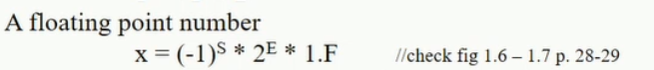
  + Notice how if sign bit is on (1), then number is negative, and if sign bit is off (0) then -1^0 = +1; so you have a positive number
* Remember for IEEE, we do not store the first one from the 1.F; only F part matters; and its ok because 0 can still be represented by all 0s; no sense in wasting a bit that will always be set to on (1) as long as value is != 0
* 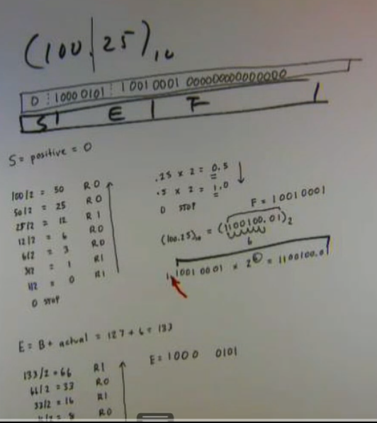
* 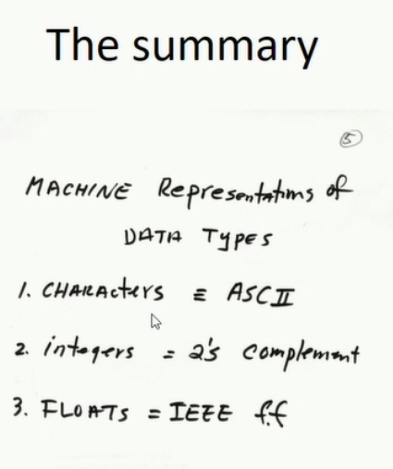
  + Remember char is 8 bits, but for ASCII representation only first last 7 bits used; first bit not used
* Remember every 4 bits represents a hexadecimal digit; so it is very easy to use this trick to convert a number from binary into hex
  + Remember, memory addresses are stored as 32 bit binary integers, so when drawing a memory map, we can use a more convenient method of hexadecimal digits to make a table of the memory map (and omitting leading 0s); a memory address is 32-bits == 8 Hexidecimal digits (8*4 = 32bits)
  + Also remember then that a CHAR can be represented as 2 hexdigits (2*4 = 8 bits)
* 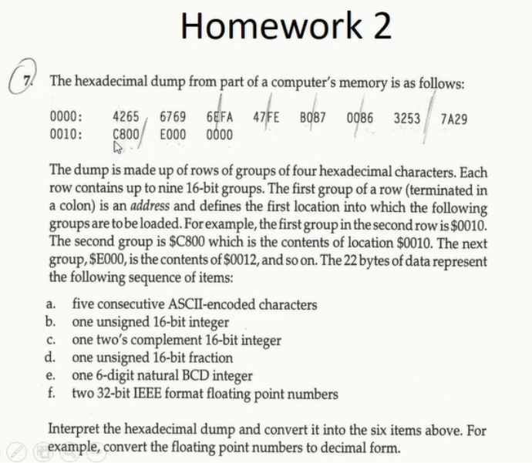
  + Above, you have to draw a memory map
  + 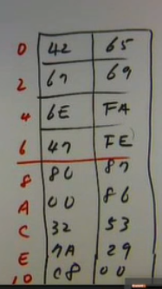
  + Above, the memory map (drawn as a 2d array from the 2 memory addresses given; with all Hex numbers used; must segment them appropriately according to what is given about what is stored at the two consecutive memory locations)
* Chapter 2 from Irvine book
* 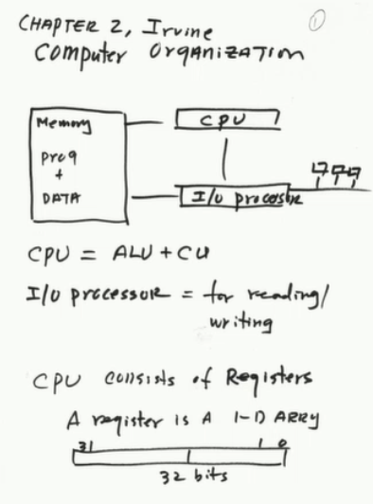
  + Remember ALU (Arithmetic Logic Unit) performs arithmetic operations and logical operations (and, or NOT, etc..)
* Simple truth: If a program never goes into memory it can never be executed. (It needs to be placed on the stack; which is a location in the RAM)
  + Then from there, those addresses can be placed in a CPU data register
* Instruction Execution Cycle
  + 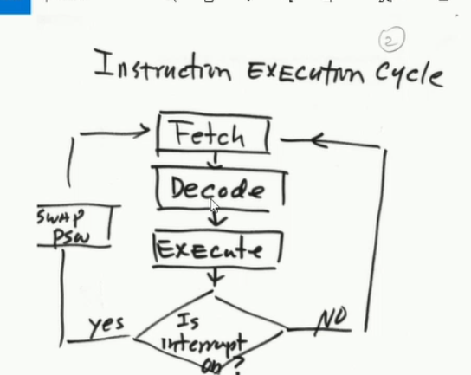
  + Interrupt bit is checked at the end of each cycle
    - For INT x86, this is the EFLAGS bits for the E register
  + PSW = Program status word
  + 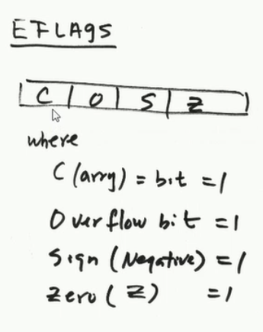
  + Remember: overflow occurs only when carry -in sign bit is different from carry-out sign bit (so sign bit in the actual number/register is different from carry-out sign bit which is stored in the EFLAGS register {which I am guessing sits right next to the ALU when a number such as floating point number or int or char is being calculated so that when overflow occurs that EFLAGS carry bit will be set and of course if it is different from carry-in sign bit then it indicates overflow has occurred and thus the overflow bit will be set as it is also likely adjacent to the carry bit so that it can be set if necessary)
    - 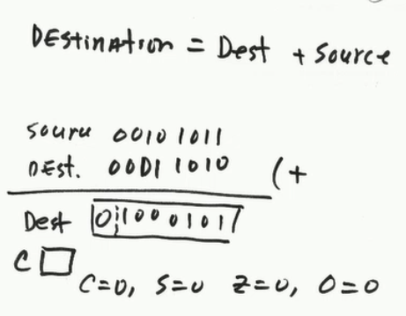
  + 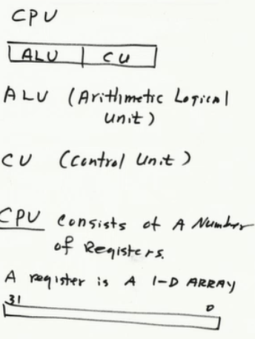
* Make sure when adding, in order to check register flags, you make the register the first operand (this is because of how the hardware works on the ALCU when calculations are made)
  + Although it is still allowed to make the register the second operand
* Remember: computer circuitry is all Boolean (logic gates)

# Lecture 5 notes - MASM – ch. 3

* .386 directive
  + Means you will use 32-bit data registers
* .model flat, stdcall directive
  + You will use flat memory model 🡪 1D array
* .stack 4096 directive
  + Tells assembler how many bytes of memory to allocate for runtime stack, by default every x86 program must have at least 4096 bytes
  + 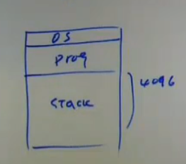
  + OS = operating system, program, stack
* Program memory model:
  + 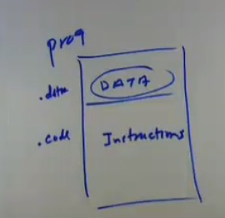
* Showing declared variables on the stack in memory (in 2 hex characters = 8 bits)
  + 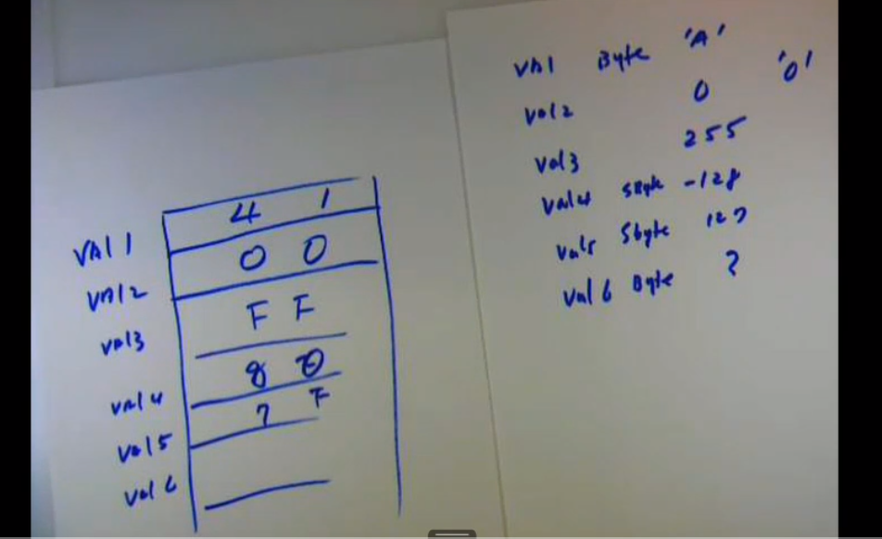

# Lecture 6 notes - MASM and ch 3 cont.

* All operations take place in the stack
* Assemble-link-execution cycle
  + assembler translates .asm assembly code into machine code 🡪 it outputs the translated assembly code as machine code to an object file (.obj)
  + 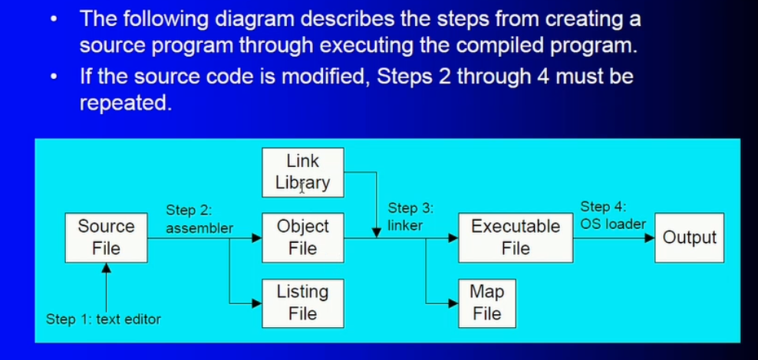
  + Loader from step 4 loads your program into RAM memory so that it can be executed
* Listing file
  + 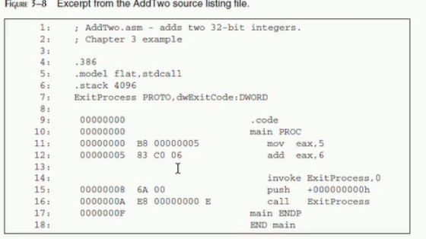
  + Above, notice it shows the 32-bit address (in hex), and then machine representation (also in hex) of the code written; so for example, “mov eax,5” in machine code is “b8 00000005”
  + So remember loader will load the machine code version of your program, sequentially and consecutively, in a memory location in RAM (1D array)
* Arrays
  + Remember, advantage of using arrays is that it is easy to access an element by simply using an offset from the start address of the array (the address of the first element in the array; i.e, the first memory location of allocation in a sequence of allocations)
    - so for example, if I have a char array (BYTE) of 3 bytes, and the address of the first char is 00000000, then to access the first element (element 0), simply use array name; to access the 3rd element (element 2), simply take the address of element 0 (start address of the array) and add 2(hex) to that start address; thus to access element 2, do element (0) address 🡪 00000000 + 00000002 = 00000002 🡪 the address of the 3rd byte in the char array.
* String is usually defined as an array of char that is NULL-terminated
* Systems based on ASCII or a compatible character set use either LF (Line feed, '\n', 0x0A, 10 in decimal) or CR (Carriage return, '\r', 0x0D, 13 in decimal) individually, or CR followed by LF (CR+LF, 0x0D 0x0A). These characters are based on printer commands: The line feed indicated that one line of paper should feed out of the printer, and a carriage return indicated that the printer carriage should return to the beginning of the current line.
* **Carriage return** means to return to the beginning of the current line without advancing downward. The name comes from a printer's carriage, as monitors were rare when the name was coined. This is commonly escaped as \r, abbreviated **CR**, and has ASCII value 13 or 0x0D.
* **Linefeed** means to advance downward to the next line; however, it has been repurposed and renamed. Used as "newline", it terminates lines (commonly confused with separating lines). This is commonly escaped as \n, abbreviated **LF** or NL, and has ASCII value 10 or 0x0A. **CRLF** (but not CRNL) is used for the pair \r\n.
* **Form feed** means advance downward to the next "page". It was commonly used as page separators, but now is also used as section separators. (It's uncommonly used in source code to divide logically independent functions or groups of functions.) Text editors can use this character when you "insert a page break". This is commonly escaped as \f, abbreviated **FF**, and has ASCII value 12 or 0x0C.
* Unit of information: BYTE, WORD, DWORD…SBYTE, QWORD…ETC.
* DUP = duplicator operator
* Also side note: we use the bias exponent for IEEE Floating Point format because we need to represent fractional and whole number parts; biased at 127 so that if exponent after normalizing a number in binary is fractional only, then biased exponent value < 127, if a number contains integral and fractional part, biased exponent will thus be >= 127.
* “call DumpRegs” is using the call directive and calling a program called DumpRegs, a program from the Irvine32 library
* Calculating the size of a byte array:
  + 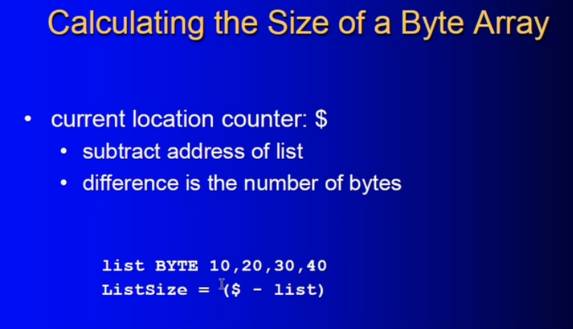
  + $ points to address of the byte right after 40 (ESI register pointer); thus $ - list = size of list
  + Remember “list” is address of first byte in the array
  + 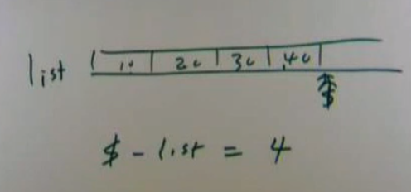

# Lecture 7 notes - chapter 4

* 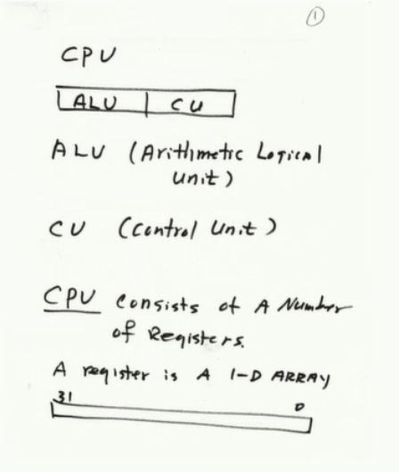
  + Add, sub, mult, divide: ALU part of CPU
  + CU: synchronizes operations
* Remember: arithmetic (add, sub, mult, div…) and logical operations (AND, NOT, ETC..) MUST take place with the involvement of least 1 register or immediate value operand (so that FLAGS will be affected and complete the operations appropriately); and operands must be the SAME SIZE.
  + Multiplication and Division must take place using EAX (and its segmented registers) since it is the register designated primarily for arithmetic operations, see Irvine book
* For example:
* 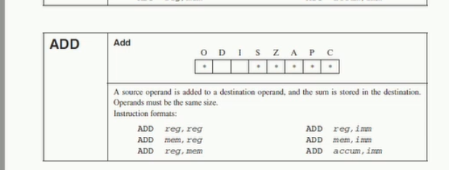
* Remember CPU accesses memory, one memory location at a time: Fetch, Decode, Execute cycle.
* If you multiply two 8-bit numbers, the most you can return is a 16 bit number, so that is why 8-bit multiplication stores its result in a 16-bit register (ax register)
  + Note if 8 bit mul returns small enough result to only take up 8 bits (AL), then the entire result will still be stored in AX, however the CF will be set to 0 to inform you that the result could fit in the 8-bit AL register (with AH zeroed out).
* Similar ideas are for higher bit multiplication, see Irvine book
* Note for division with 16 bit division: DX:AX/(reg, mem, imm) 🡪 stores quotient in AX, and remainder in DX; the reason or DX:AX is because DX acts as only a place holder, but then after the operation it holds the remainder. So, **DX must always be cleared (zeroed)** since it functions as a place holder when it is the dividend (and then after it becomes the remainder holder)
* Same idea works for 32-bit division
* Immediate values are called immediate because they can be evaluated and moved to a register in 1 unit of time (just like register to register); also the value is encoded within the instruction
* However for memory value to a register takes 3 units because the memory location has to be fetched, decoded, then executed
* VERY USEFUL move INSTRUCTION: MOVZX: when you copy a smaller value into a larger destination, the MOVZX (move, zero extension) instruction fills (extends) the upper half of the destination with zeroes.
* 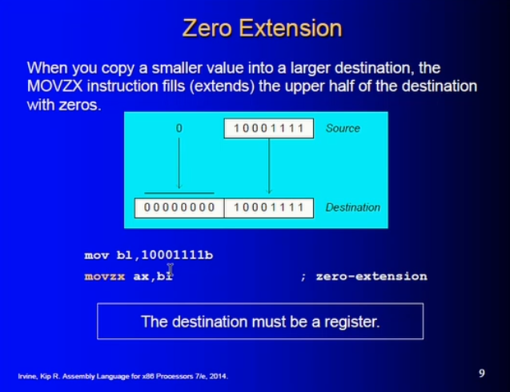
  + From chapter 4
* MOVSX extension does the opposite of zero extension move instruction:
* 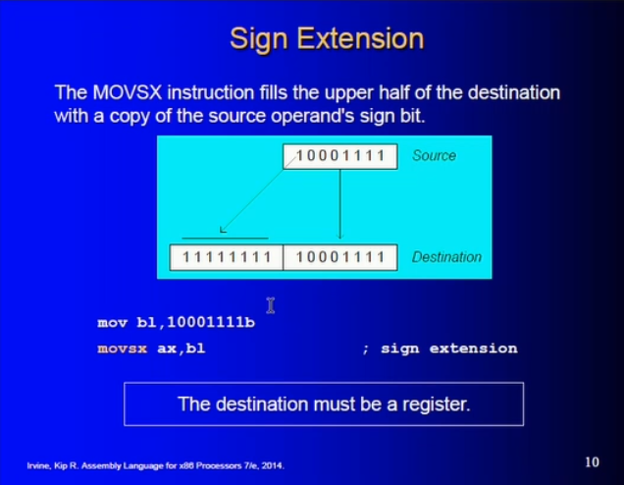

# Lecture 8 notes -

# Lecture 9 notes -

# Lecture 10S -

# Lecture 11S -

# CIS 310 – PART 2 - SUMMER II with Abou Nasr

# Lecture 1 – combinational logic – part 1

* In order to design a CPU to understand a certain language that you have in mind, you need logic gates: you to essentially become a logic engineer (particularly an electrical and electronics engineer)
* Truth tables and logic can be represented by a circuit
* George Boole is where Boolean logic came from: idea that human thought can be encoded by logical expressions
* Goal is to represent logic broken down into only two states
  + This means of course you may need a large amount of logic to describe a complex logic
  + But this is why the binary numbering system is so handy in digital systems
* For truth table: number of rows that you will have depends on number of variables: it is a function of 2n, where n is the number of variables
* Boolean operations have rules of precedence
* Goal is always to build the simplest circuit: less expensive, less power consumption; so we must always try to build the most efficient, non-redundant, compact logic gates (circuits) possible to solve a problem/solve logic
  + Minimize the expression as much as possible to use less circuits/gates; keep cost down, and circuit will not only consume less power but it will run faster and more efficient
    - And more simpler to implement
  + Use Boolean identities
* Example of simplification using various Boolean algebra laws:
* 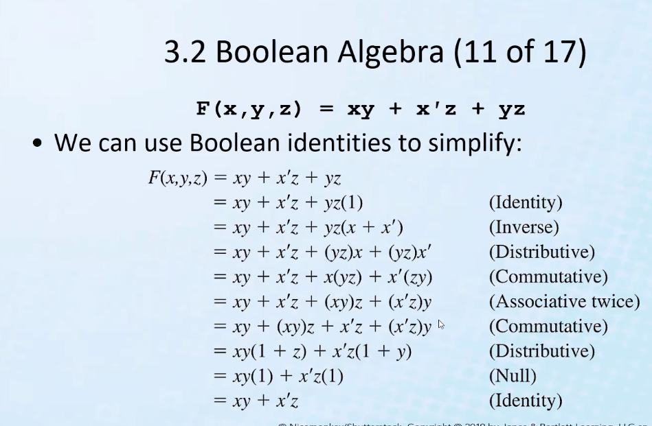
* De Morgan’s law: invert all terms separately, and the ANDs becomes ORs and vice versa.
* 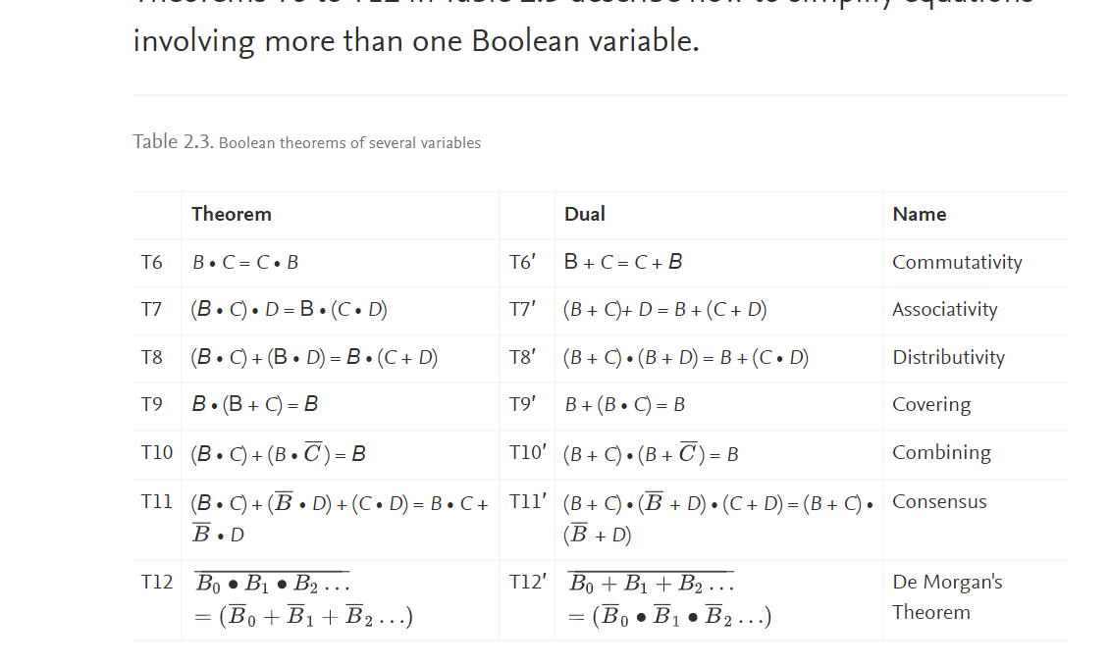
* 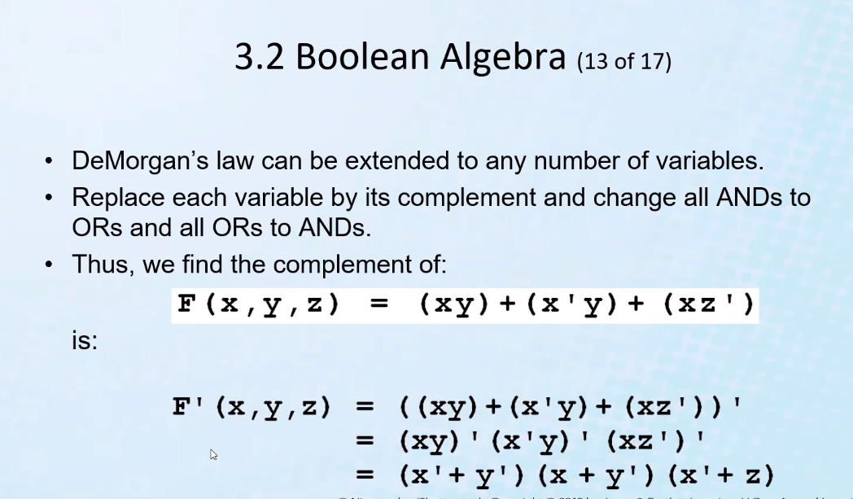
* Logic functions can be written in more than one way (logically equivalent functions); we pick the one that is best suited and most efficient for a given situation
* For sum of products canonical (standardized way) of representing a logic function:
  + Make truth table
  + find all rows where final result of function is 1
  + multiply all variables together to get 1 (thus, if any variable is 0, it must be NOT-ed)
  + then sum up all of the rows where final result is 1; thus you will get a sum of products
  + 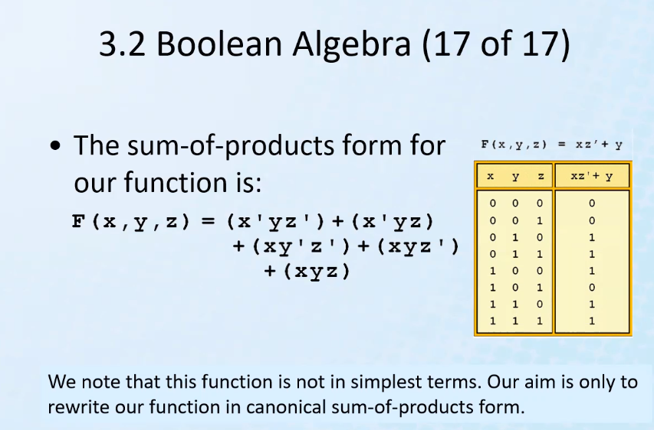
* The CPU of a computer is an integrated circuit, which integrates millions of sub-circuits/gates
* It is more efficient for manufacturers to manufacture more advanced gates (such as NAND, XOR, etc) and combinations of those gates since they will be widely used and it is easier to develop less components and manufacture a smaller set of more advanced gates
* The more advanced gates can also be connected in a certain way to make the equivalent of the more simple gates, but not vice versa ( it is not as easy; thus it is not as efficient to manufacture so many different components; thus, simply implmenet a few advanced components that can handle most of the gates or gate equivalencies that are typically desired).
* 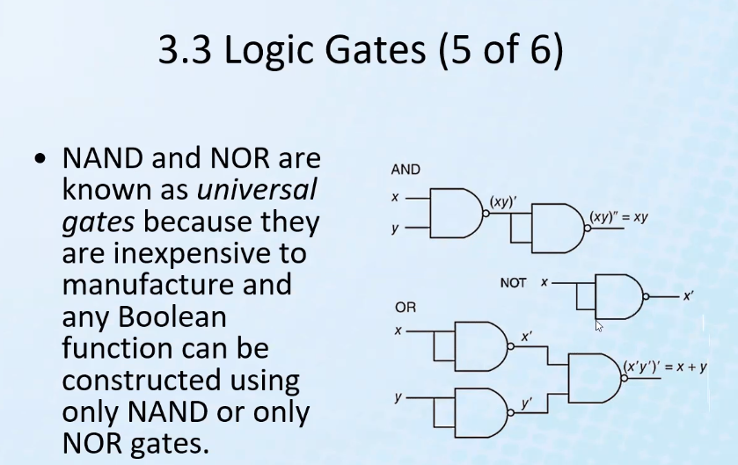

# Lecture 2 – combinational logic – part 2

* Karnaugh Maps – mechanical way to reduce a Boolean function
* 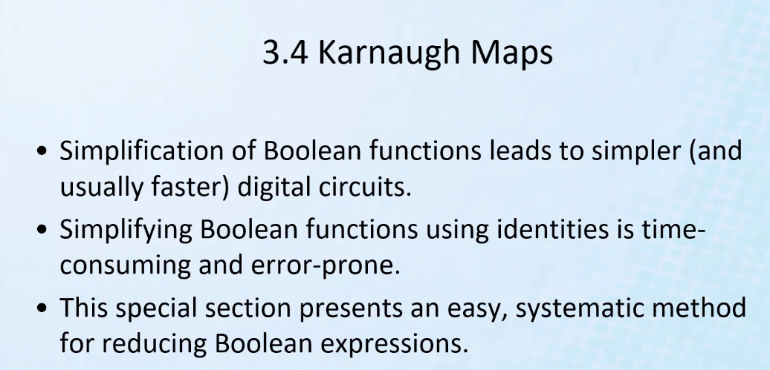
* Number of min terms of a boolean function = 2n, where n is the number of inputs/variables
* 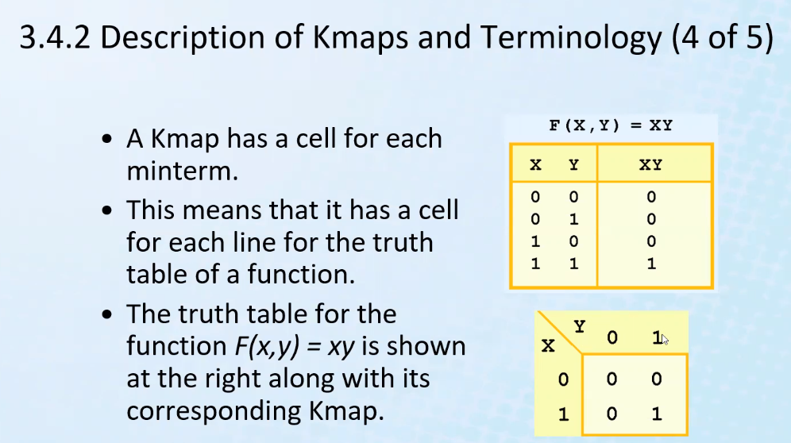
* As you can see, the K map equivalent of a truth table is more compact and is a matrix
* Number of cells in the matrix = total number of min terms
* Same ideas apply to an OR k map:
* 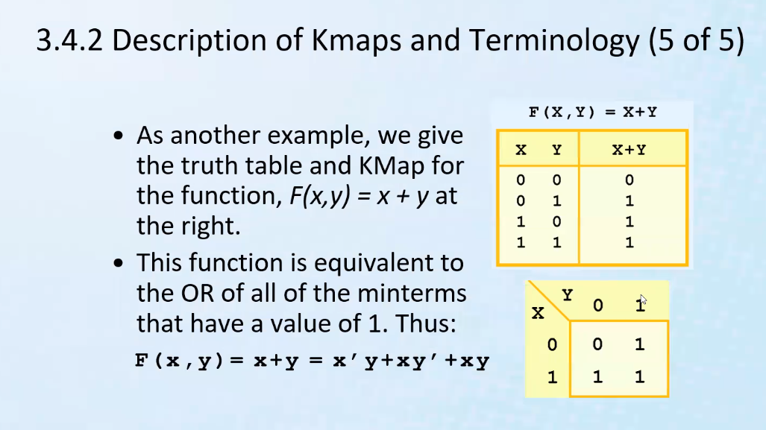
* Remember, variables are all true (1), so when they are 0, it is inverse of that variable (x’ = 0 for ex.)
* 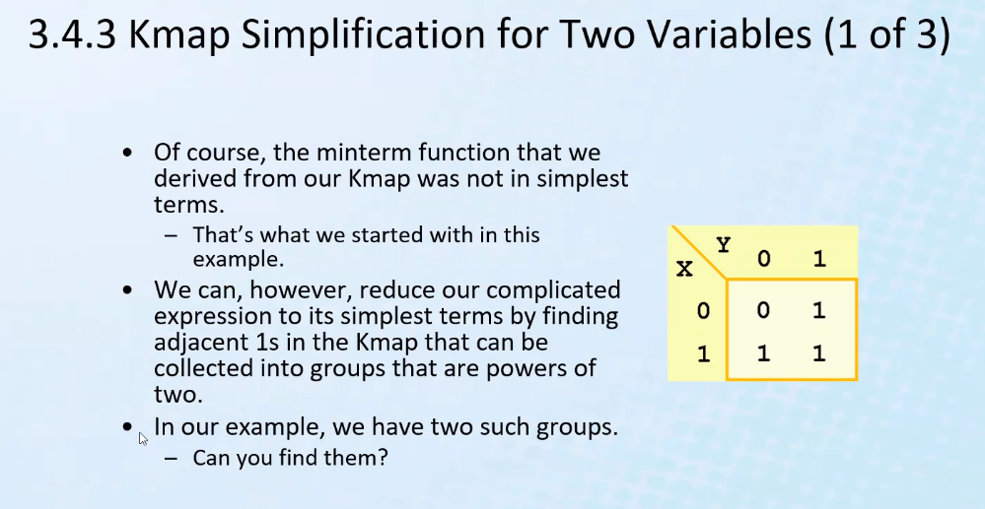
* 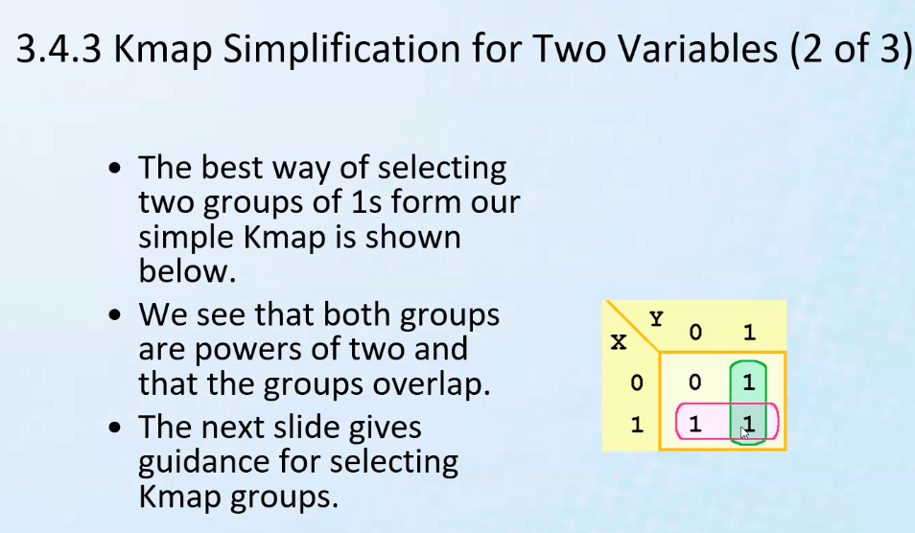
* Karnaugh was especially interested in SIMPLIFICATION of boolean logic
* 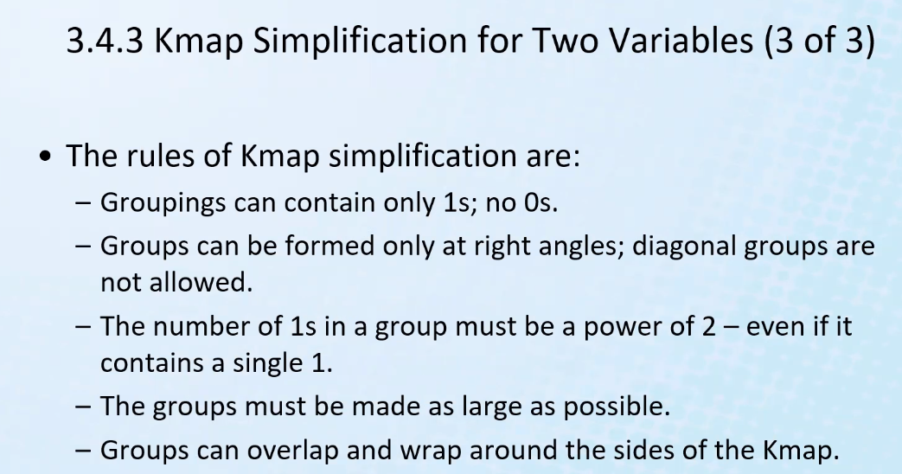
* Wrap around: the left and right sides of the matrix are considered adjacent
* 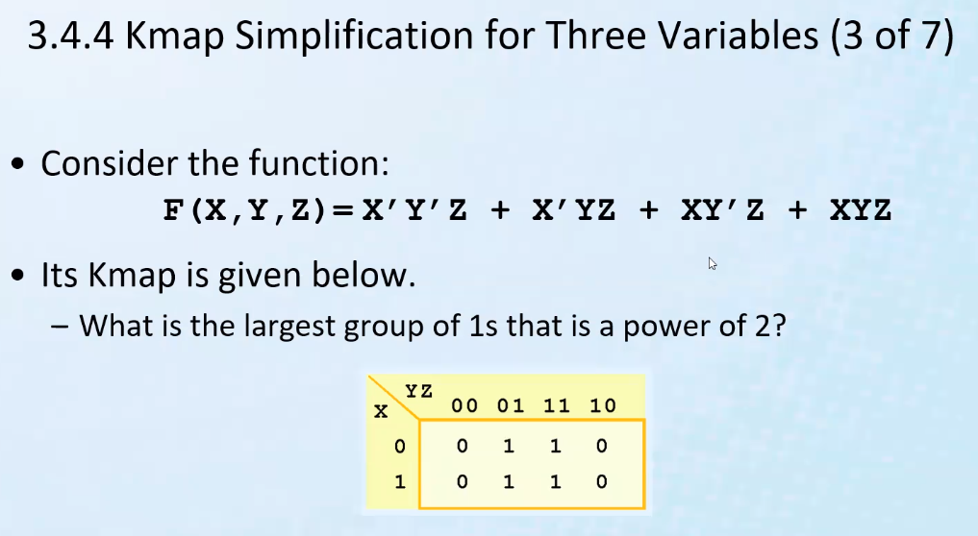
* Notice the mapping is still made 2-dimensional
* Also a rule: the next column must only differ from the previous column by only 1 bit
  + So 00 and 01, differ by 1 bit, but 00 and 11 differ by 2 bits
* You can also have a square of adjacent ones, that are considered a group; above, all 4 ones form a square and are the biggest group:
* 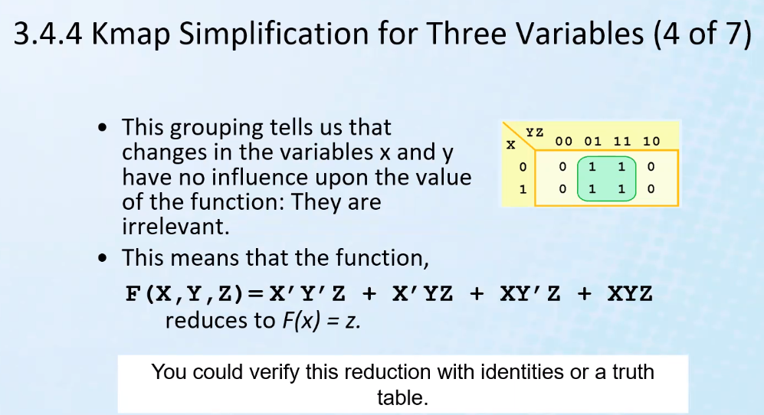
* Notice above, for 01 and 11, the result of the function did not change when variable Y was changed; thus it is irrelevant and it can be ignored
* Same idea applies for when x is 0 and x is 1 for the adjacent column of 1s
  + This the x can be ignored in those groupings since output is still true no matter what the value of x is
* Thus: x and y has no effect on the function at all based on the above k map, thus, the function is reduced to z
* 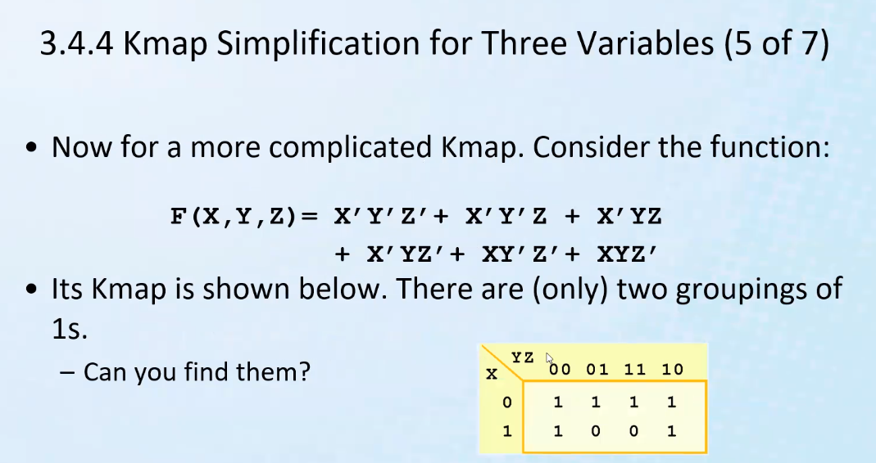
  + Remember edges are adjacent
* 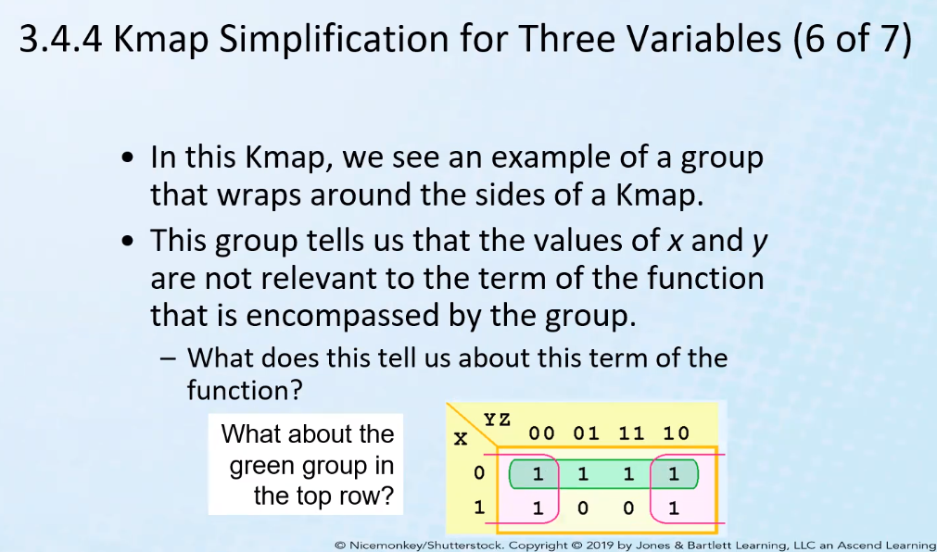
* 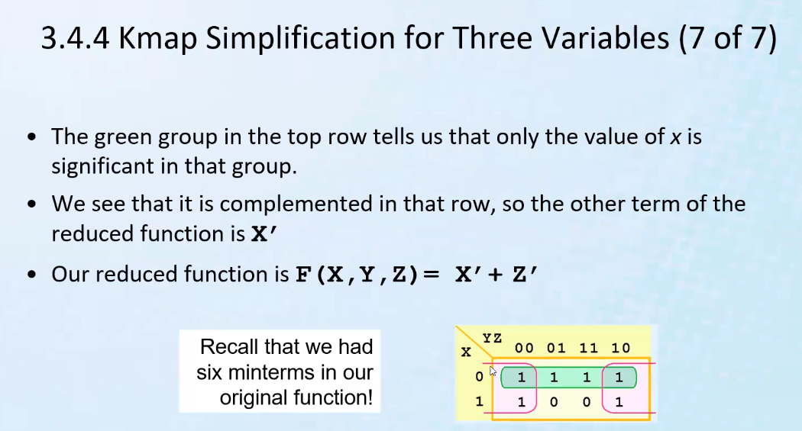
* So for the green group, Y and Z are irrelevant; it only matters for X, in this case, X’ (X = 0)
* For pink, when z = 0 (Z’), that is the only thing that makes the function true (1)
  + We change x and y values, and the function remains true; thus we see that the output depends the value of z
* So function reduces to x’ + z’
* Remember, adjacency is a key component as to our rational for using these maps for reducing a function
  + Adjacency is important because you can see what variables change value, while the output remains the same (1 = true); then you can find which variables are irrelevant for a given group in relation to other variables, and you can find which are the only relevant variables that actually change the value of the output
* You might choose a different set of groupings, but you will still get the same reduced form function
* 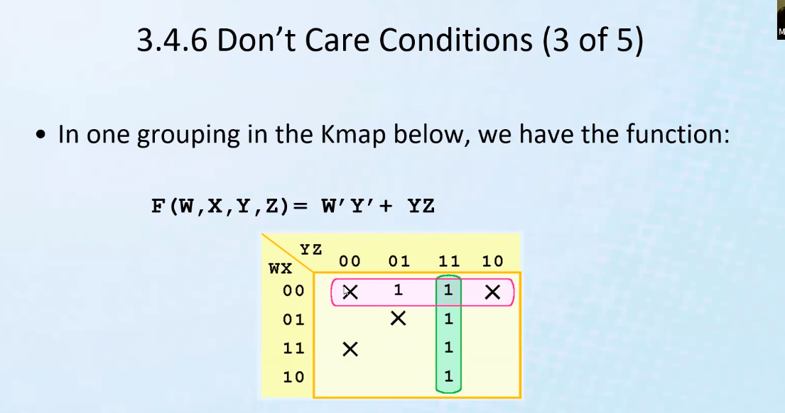
  + X means it can be any value (0 or 1, depending on whatever you choose or need)
* Main idea of K map is to reduce a function
* 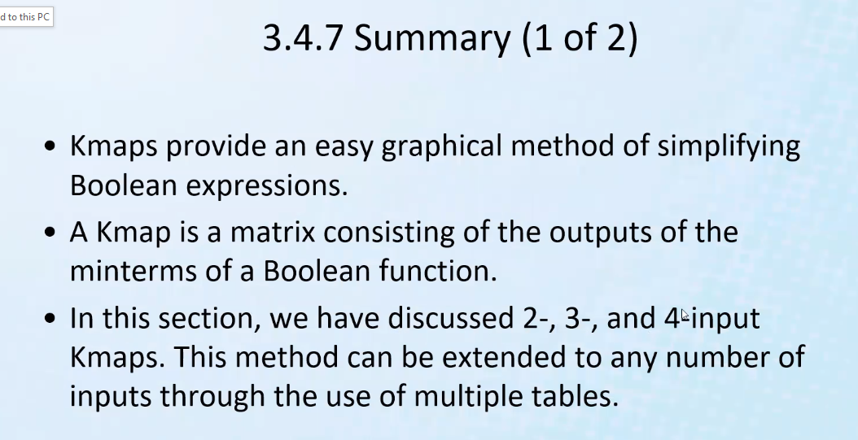
* 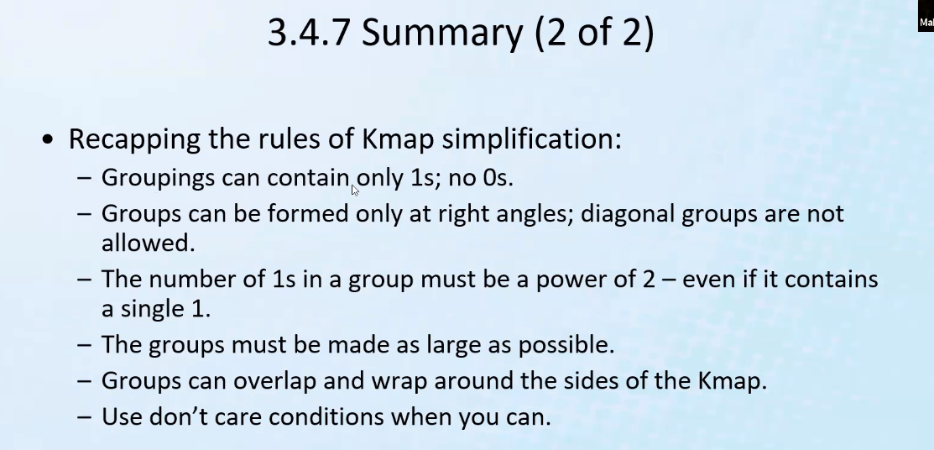
* Variables in a bool function = inputs (electrical inputs)
* We use truth tables to look at the details of a problems expressed as boolean logic
* We can derive a circuit from a truth table or a k map
* When we write programs, we right logic based on another underlying logic: combinational and sequential logic circuits
  + So logic atop logic: abstraction concept is shown
* Remember XOR gate resolves to true only when inputs are different (0 when they are the same)
* 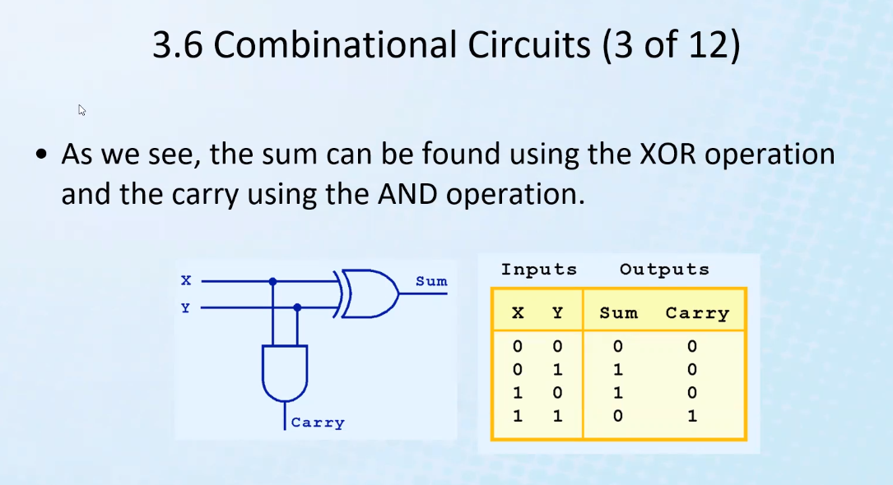
* Above, we use XOR, and also AND gate for Carry because only true and true resolves to true, so we know that is the same as what an AND gate represents
  + Above is called a half adder because it is only 4 bits used for sum and carry
* 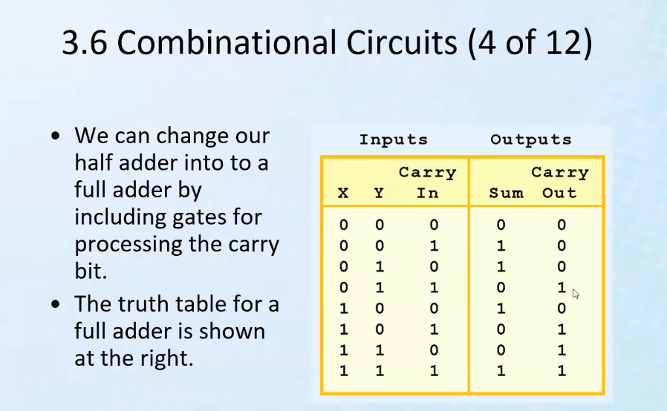
* Above is a full adder
* Carry in comes from a different instance/stage of previous addition
* 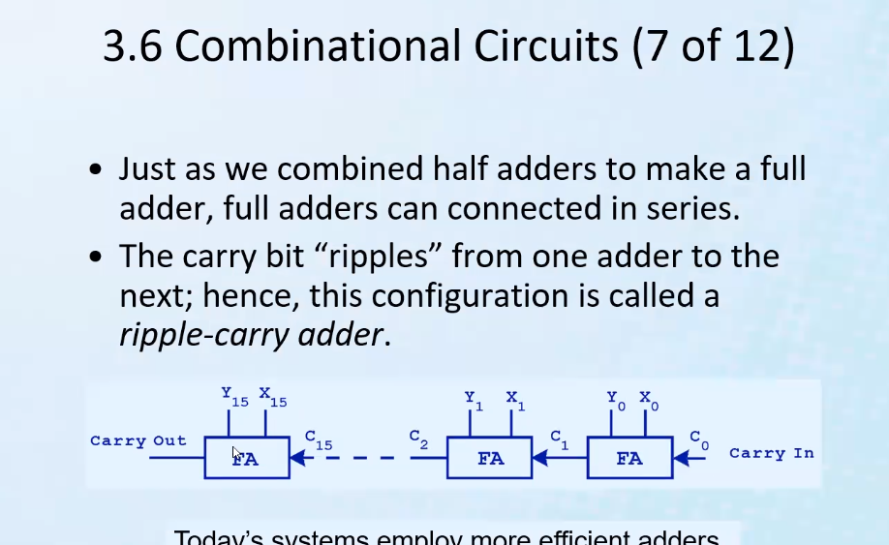
* C refers to carry values from previous sum operation
* 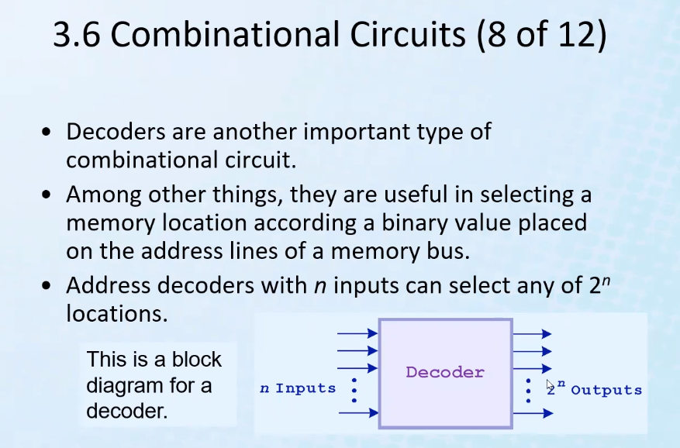
* Advantage of a decoder is that you can have less inputs and still access more memory locations by getting more outputs than inputs.
  + So for example, if you have 1024 memory locations, you will only need 10 inputs! (2^10 = 1024)
  + Or, if you need 512 memory locations to access, you will only need 9 bits (inputs!)
* 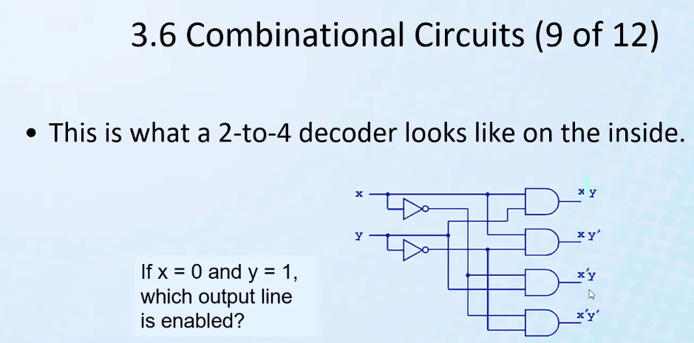
  + Notice you can duplicate inputs by a parallel circuit connected to the input
    - Simply split the input onto to wires so as to duplicate!
* 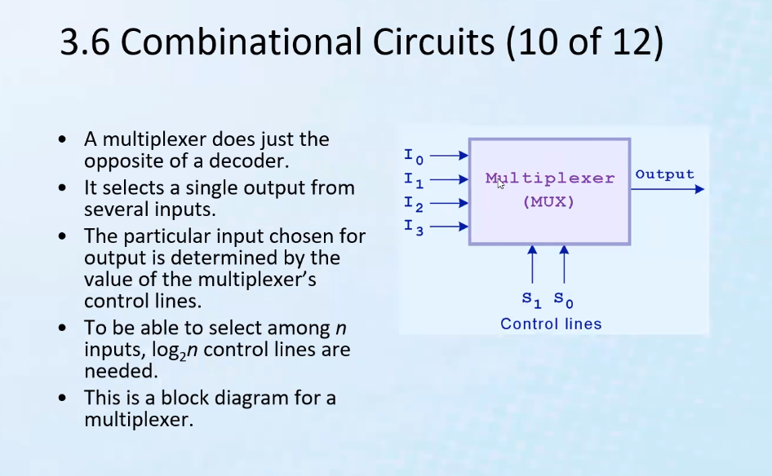
  + Takes more inputs and reduces them to a less amount of outputs
  + Above, notice you only need two inputs to choose between the 4 inputs for determining the output; 2 bits = 2^2 = 4 combinations (log_2(4) = 2)
* 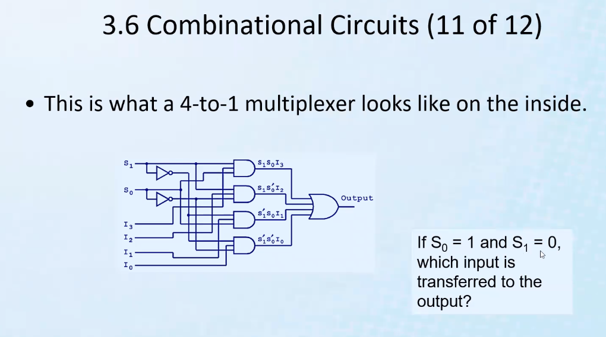
* 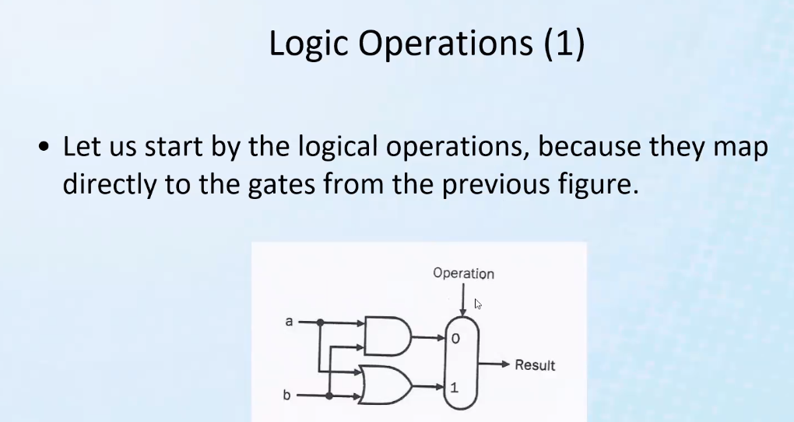
  + Notice above, the multiplexer is connected to two operations to select between or input (an AND and an OR gate operation); you only have 2 operations, thus you only **need 1** bits; 0 for AND, 1 for OR gate operation
  + If selecting between 4 operations: you need 2 bits (2^n = 2^2 = 4 combinations possible)
* 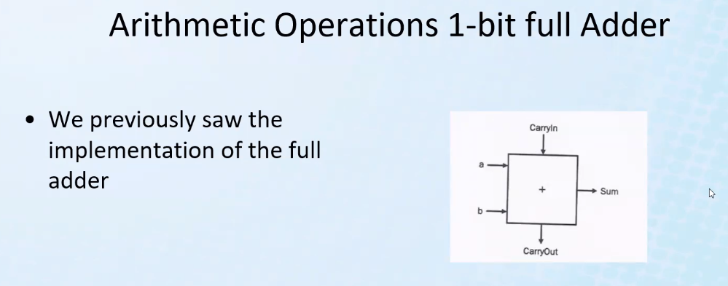
  + Carry out is used for the next stage and is sent to the carry in input
* 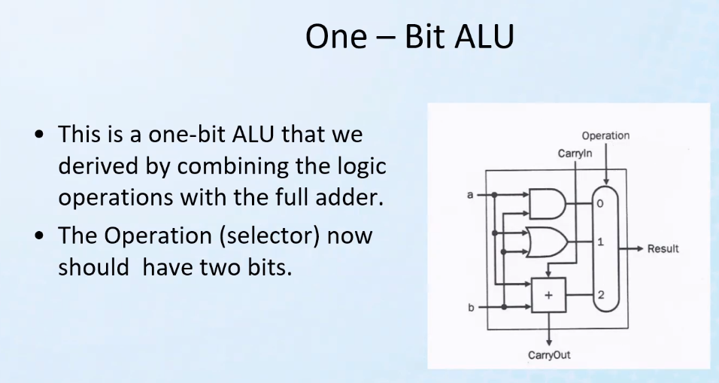
  + All operations are calculated, but now with an instruction, we can select through the multiplexer which solution we want to select/use
* 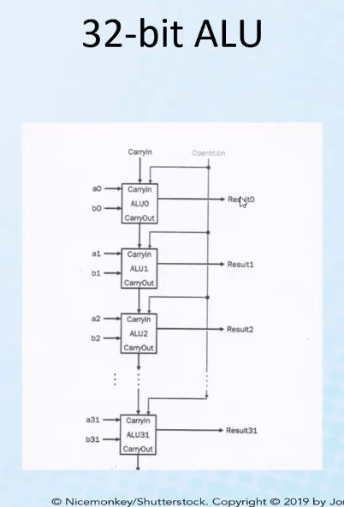
* Remember you can do addition, subtraction, AND, OR..etc..operations with an ALU
* Notice how carry out is sent to the next sub-ALU as the carry in signal; this bit is used to carry just like normal addition when we have to move to the next power and add.

# Lecture 3 – sequential logic – part 1

* For combinational logic, a set of inputs through a given set of gates produce an instantaneous output
* Sequential logic can implements logic where the desired final output is not instantaneous
  + Allow for intermediate stage logic
* Think about the Fetch, Decode, Execute (FDE) cycle; a sequence of steps needed to finally execute some instruction
* A clock is a type of sequential logic that controls the CPU to synchronize it and tells it what to do each clock tick in order to execute the FDE cycle
  + Similar to a metronome
* Of course clock speed is one of the determinants for how fast instructions can execute (thus how fast a computer runs)
* 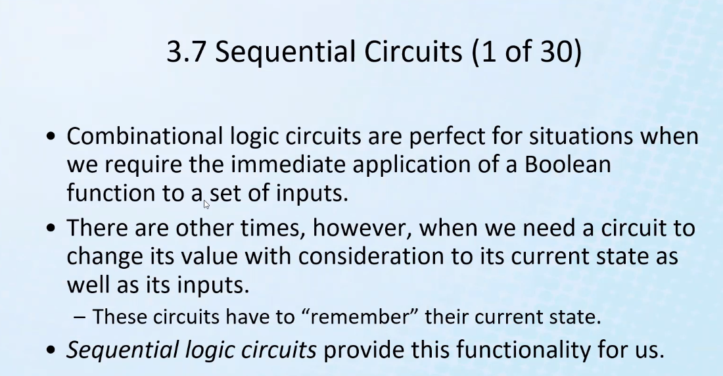
* Example of combinational logic: arithmetic logic unit (ALU)
* Think about finite state machines from CIS 306
* “state” is memory or “history”
* 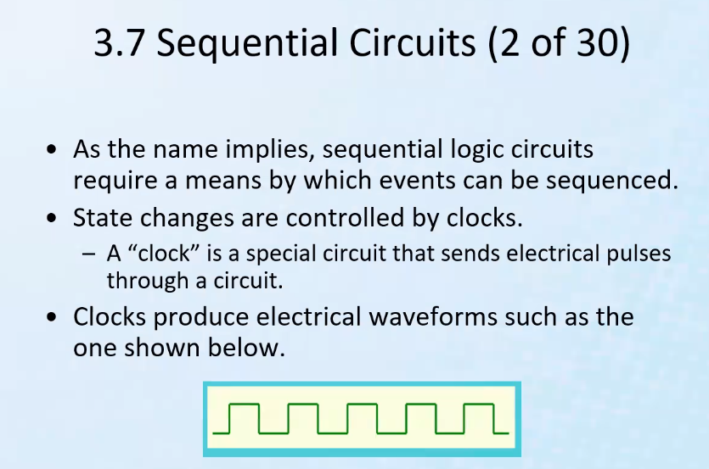
* 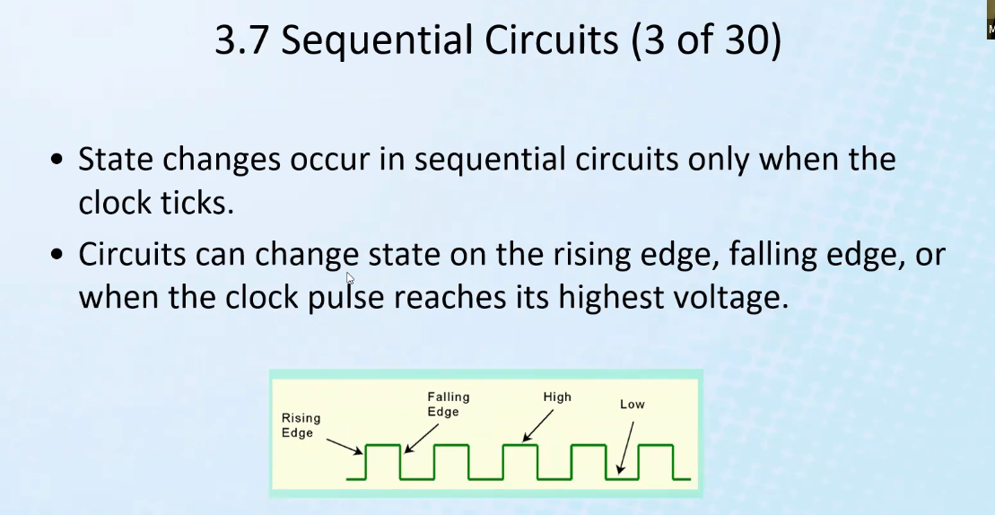
* In between ticks, the state is steady
* According to the manufacturer/designer, changes can be made on the rising and falling edge
  + Changes of state only happen on rising or falling edge of clock cycle
  + You can make circuits that work/change with rising or falling edge or based on level (high or low state)
* 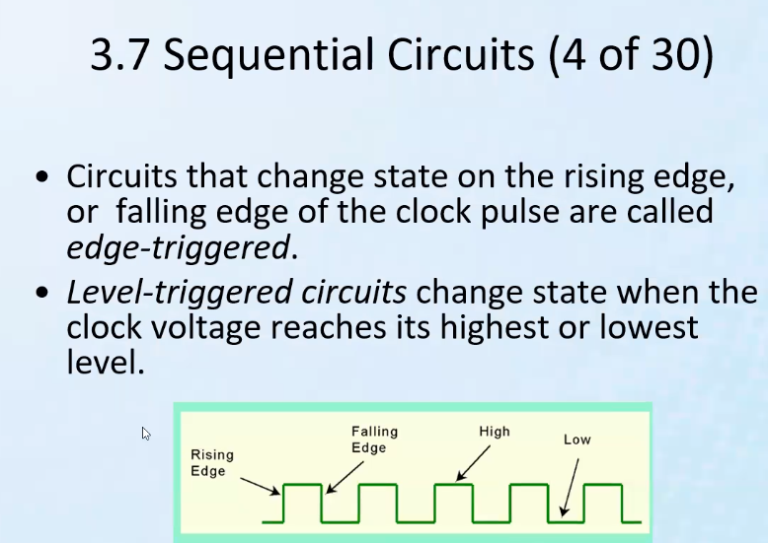
* Feedback:
* 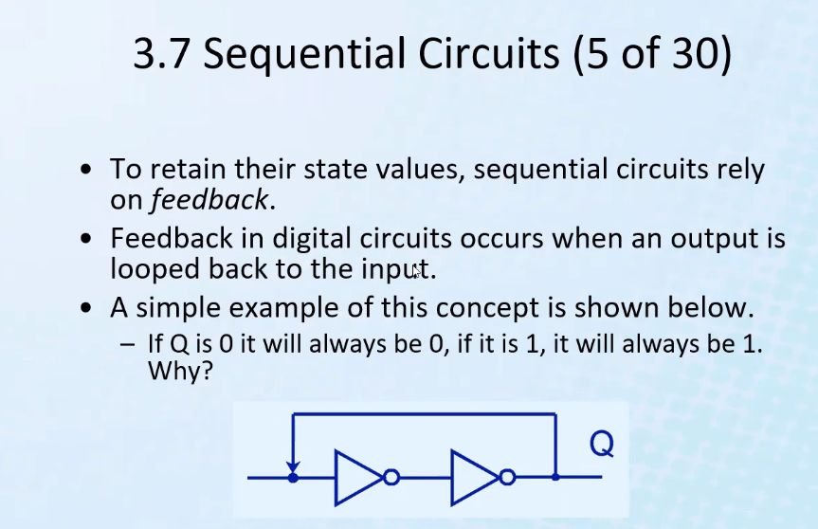
* Think about circuits! Remember from CIS 381 (ind. Robots) ladder logic circuits, how you could remember the previous output (state) by feeding output back to the input to keep the motor in the “on” or “off” state; it “remembers” through feedback.
  + It’s a form of memory
* 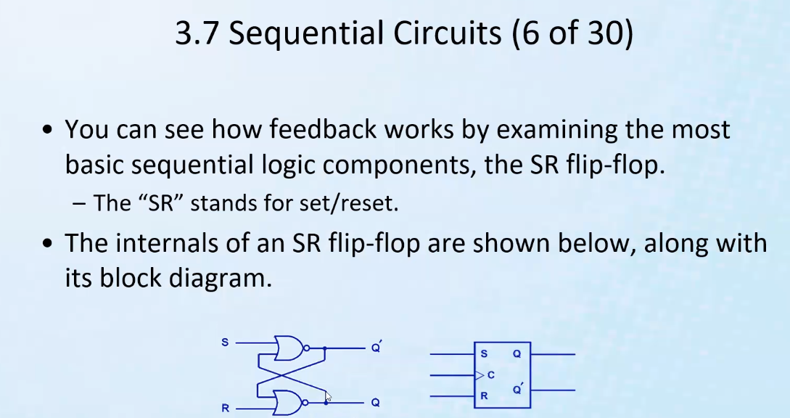
* Remember flip flops from CPU video I watched on youtube!
* C is for clock; outputs do not change until next tick of the clock (next clock cycle)
  + So you see circuit changes is controlled by the clock
* Characteristic table:
* 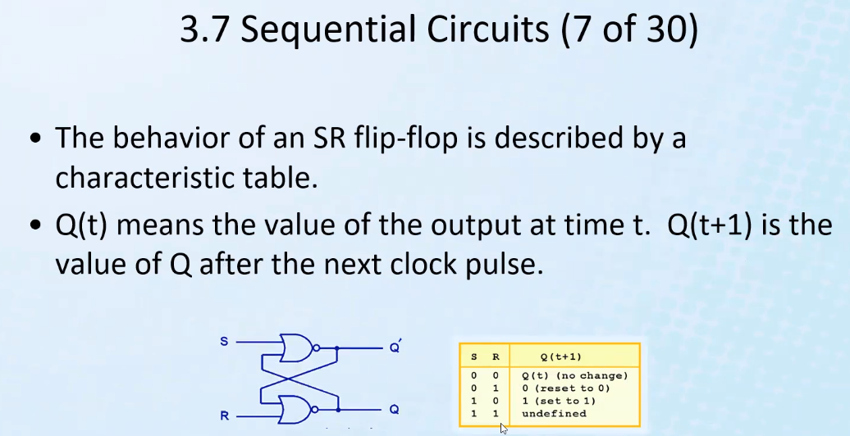
* Time t represented by the clock
* State of Q will not change for s = 0, and r = 0 at time t or at time t+1
* Set (make things 1), reset (make things 0)
  + Notice flip flop action of inputs and the given output
* So we can control the value of Q using proper input pairs and a clock tick
* 1 and 1 would make the circuit unstable
  + It will settle on something, but there is no way to know
* The first 3 in the table are the useful things in designing sequential circuit
* 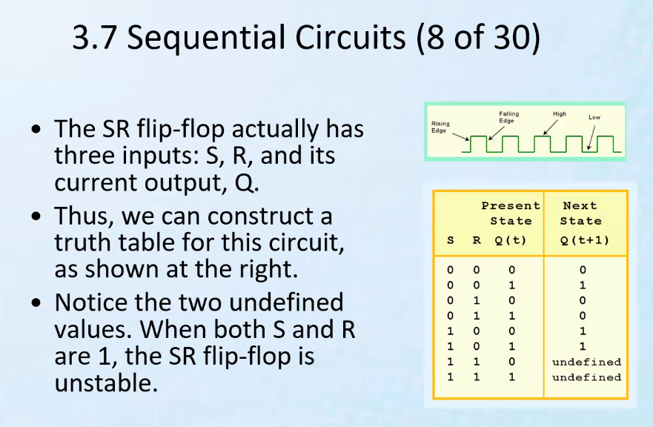
* Think about set and get wires in a CPU
* Notice where the state changes (0,1 or 1,0) and where it doesn’t (inputs are 0) and where it is unstable (undefined; does not settle on a single state); related directly to the last slide (slide 7)

# Lecture 4 – sequential logic – part 2

* Remember for sequential logic, outputs do not occur immediately for a given set of inputs
* 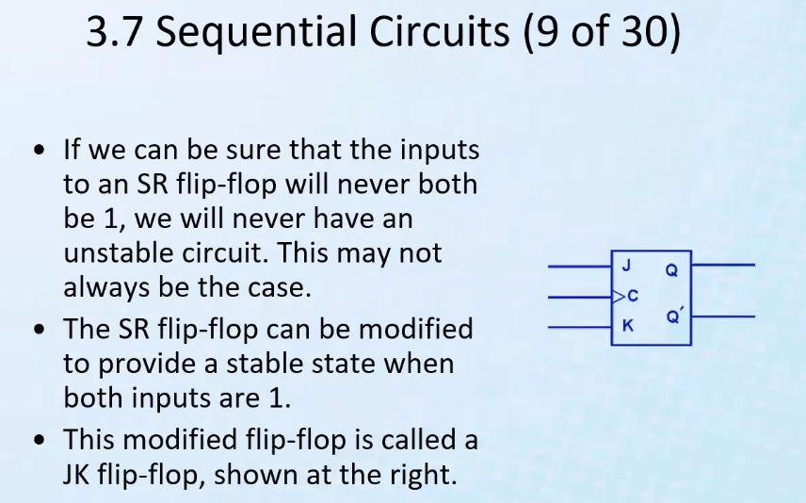
* Remember jk flip flops from CIS 306
* Jk flip flop helps with the undetermined case of SR flip flops
* 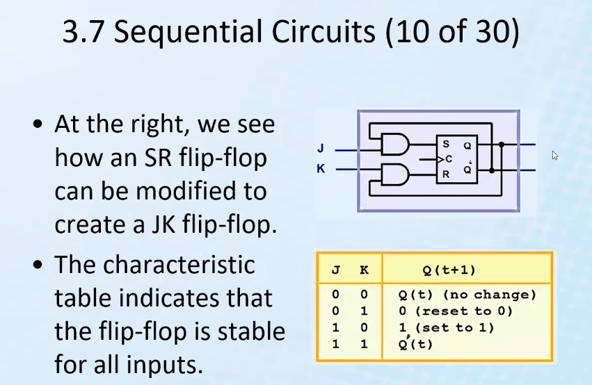
* Notice unlike SR flip flop, all inputs are stable
* D flip flop
* 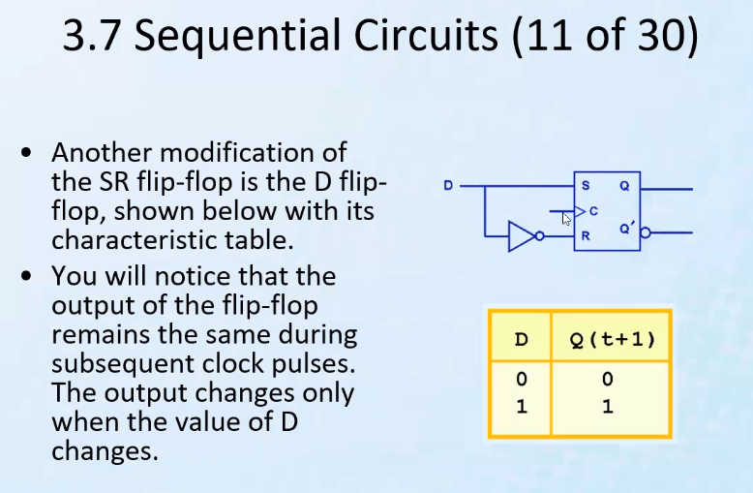
* Notice D input eliminates unstable case (1,1)
  + Gives only the option/control of one input, and the two inputs for S and R will automatically be determined
* 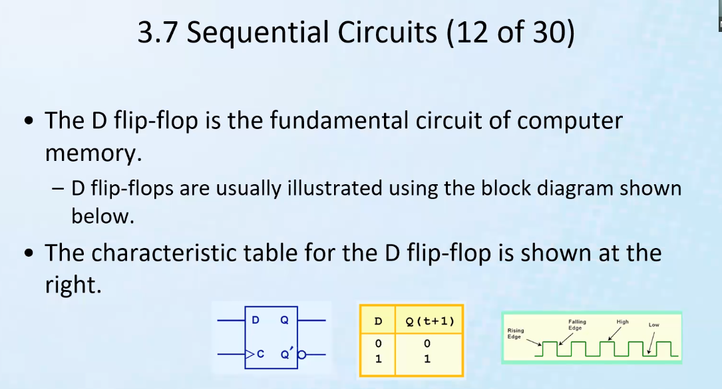
* Finite state machines:
* 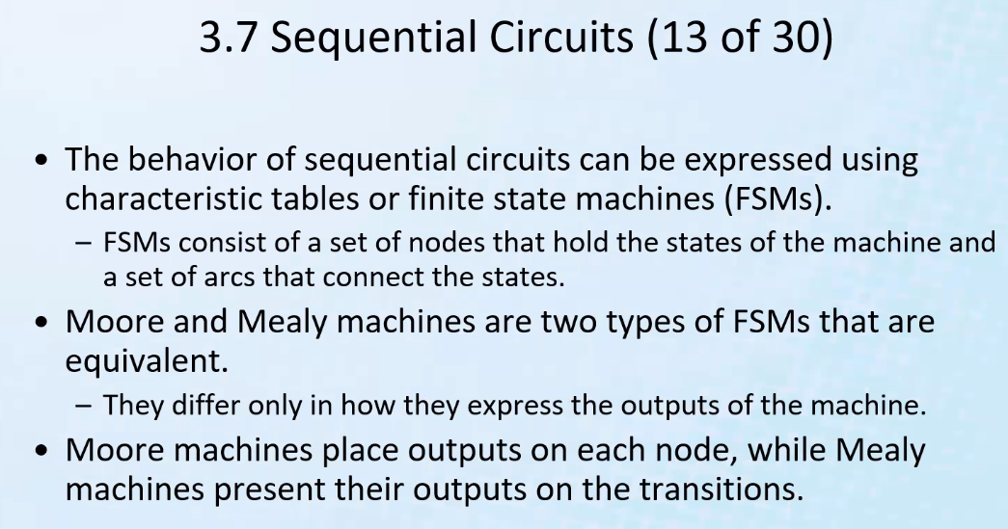
* 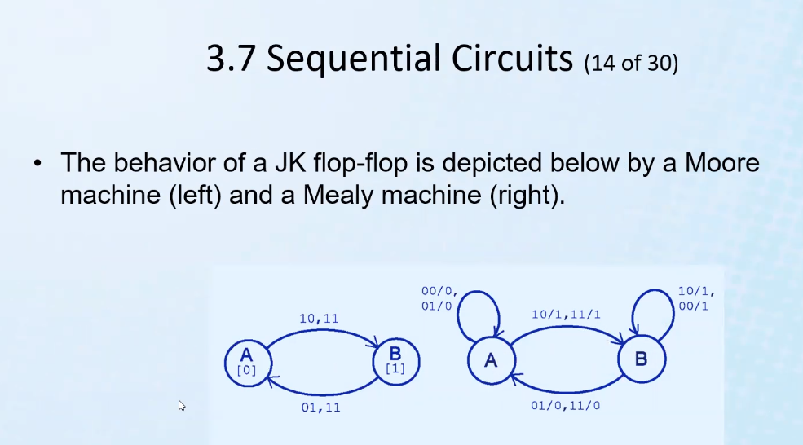
  + 1,0 (for example) represents the two inputs j and k for the moore machine
* 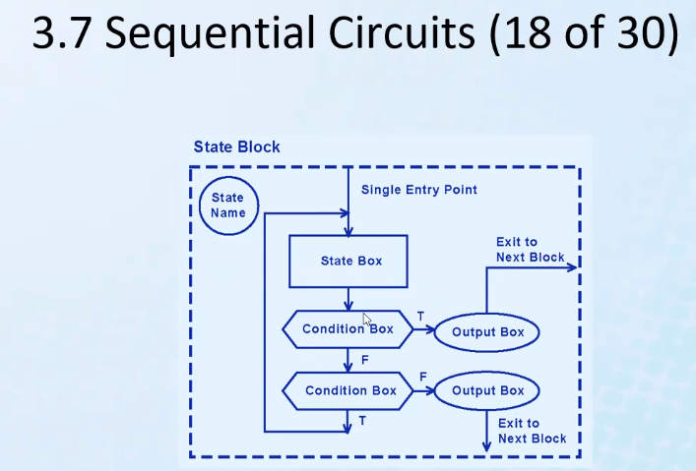
  + Above, a sequential circuit that can be used to solve an algorithm
  + Can be used to represent any program; each state (box) represents modules of the program/circuit/algorithm
  + Notice there can be only 1 entry point (think of int MAIN) but multiple exit points
* 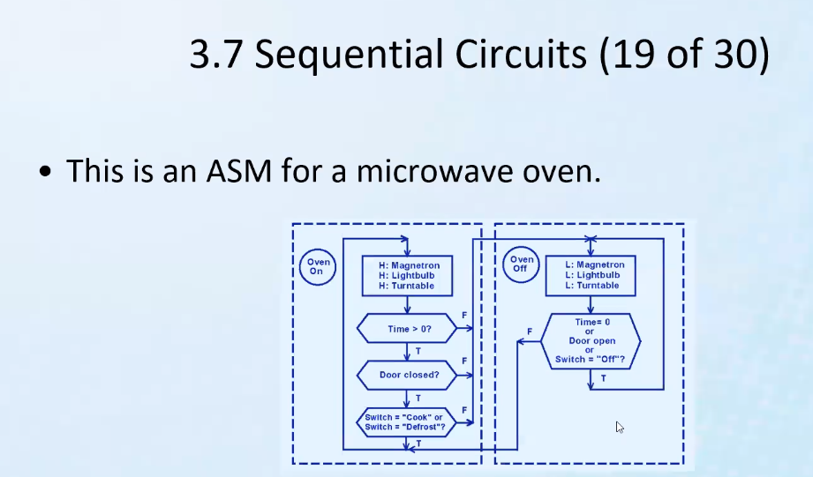
* 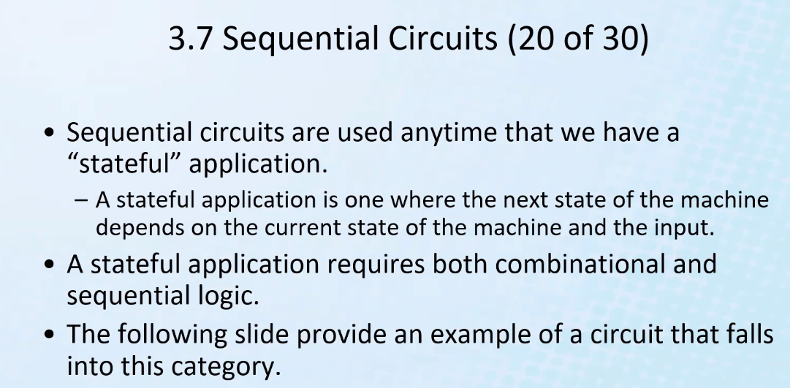
* Sequential: it remembers/considers current state before determining outputs
* 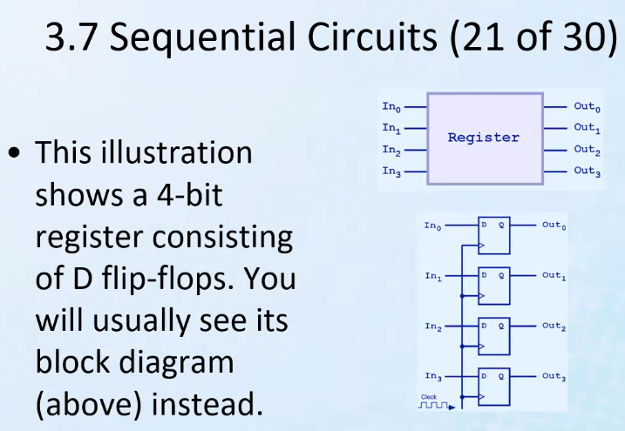
* Higher level languages hide (abstract) the details of the CPU
* For assembly language, you must know and understand the CPU/computer architecture you are working with
* Above, we are working with set and get wires just like I learned from watching the CPU video
* If inputs are not changed and next clock cycle does not happen, the outputs will not change; thus you can store/save those outputs in the register indefinitely so that you can use that saved/stored data for some other purposes
* Clock is connected to each D flip flop
* Above can be used for saving data into a register or in other types of memory
* For DDR memory, the first D stands for “dynamic” and refers to the fact that you have to refresh the circuit so that capacitors can keep their proper charge to store the memory and not lose it; this is also why it is considered volatile memory
* The other D stands for Dual-edge (or DR = dual rate); it uses the rising and falling edge of the clock so that you can double the speed of the computer memory
* 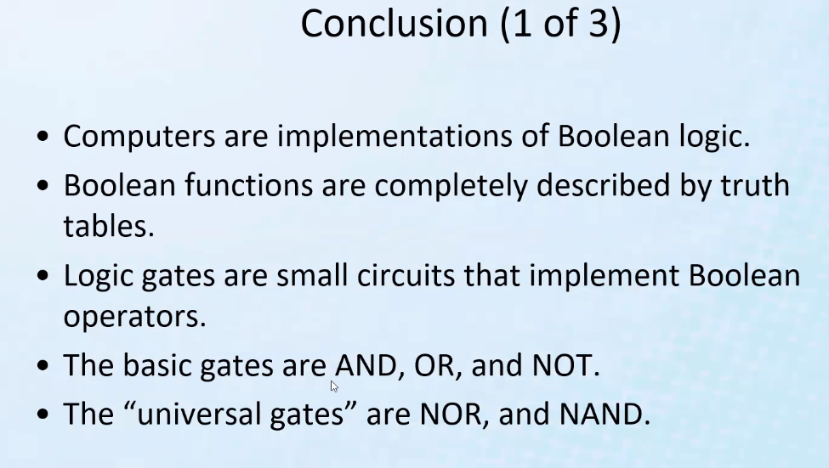
* 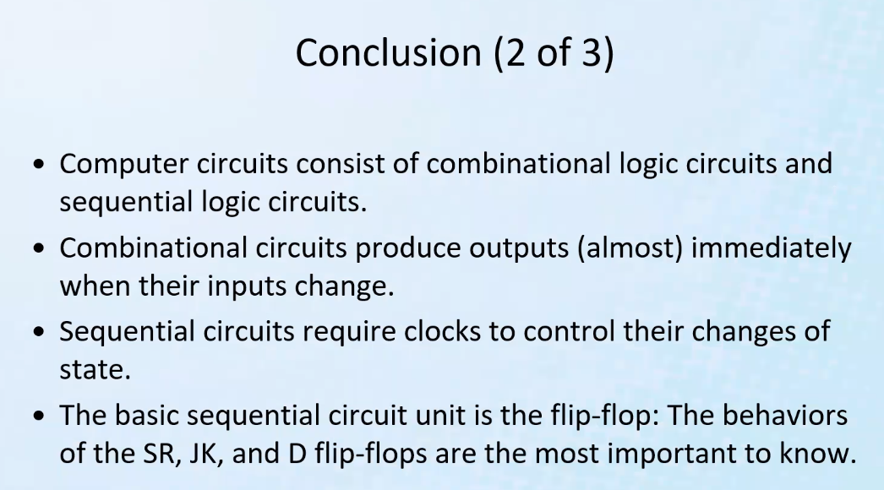
* Side note: rising and falling edge of a clock could represent the fact that when the clock is activated and completes the circuits, charge can flow and build up (say on a capacitor) or be released and thus can allow for change of state
* 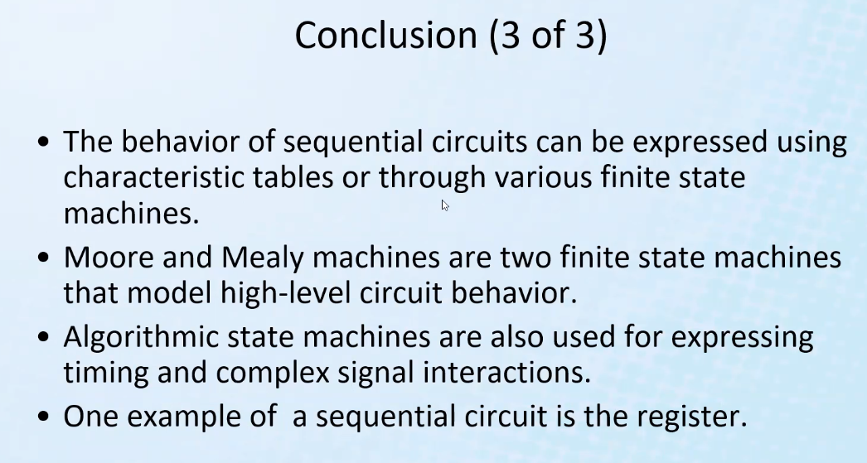

# Lecture 5 – Memory Hierarchy part 1

* Memory lies at the heart of the stored-program computer
* Think about L1, L2, and L3 cache, random access memory, permanent storage memory (non volatile)
* Remember, all instructions are stored in memory
* Think about OS, how it is stored on the disk, and loaded into memory, starting at the entry point of the OS program (first instruction) and continues decode and execute instructions until the program is loaded into RAM memory
* Types of memory:
* 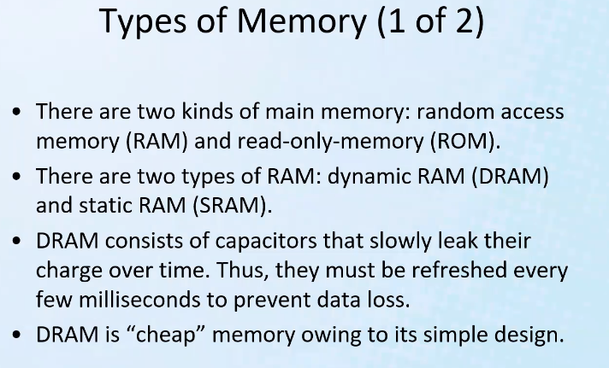
  + In the past, memory used to be stored on magnetic tape, and you had to access memory only sequentially (think about CIS-306, the original finite state machine that could move along a “tape” and read and write data in memory)
  + So you don’t have to start at beginning of memory, you can start at which every byte you need for RAM
  + You only write to ROM once (sometimes more if it is modifiable ROM)
  + Dynamic RAM is dynamic because it constantly needs to be refreshed (the charge)
  + DRAM is very cheap (but volatile)
  + Static RAM is still volatile and a lot more expensive with a more intricate circuit design that improves speed greatly and that doesn’t require constant refreshment like DRAM; (so phones and other mobile devices I would guess use this kind of RAM more in order to save battery power! But of course at the cost of more expensive phones)
* 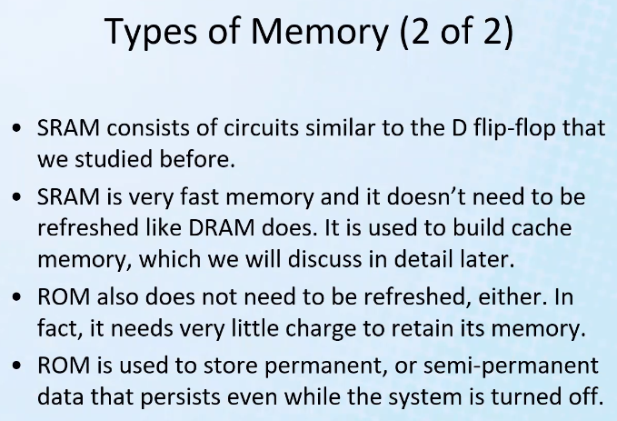
  + Of course cache memory is important for recalling memory quickly! So this is why sRAM is especially important; provides faster access time to recently accessed programs/blocks of memory; this is also why mobile devices often (likely) use lots of sRAM so that we can save battery and also to have much faster phones that are able to go from app to app quickly without having to close and reopen or recall data from slower memory (with slower access time)
    - SRAM 🡪 CACHE 🡪 MUCH FASTER MEMORY ACCESS TIME
    - Expensive, so we limit the amount we put into a computer; but also because a computer needs other types of memory
  + ROM is very good at keeping its memory with very little charge; so that’s why we can use a small CMOS battery so that even when computer shuts off we can keep ROM memory (which may store the BIOS system of a computer)
    - Little charge needed, so ROM will last a long time with a small little battery
  + ROM is a semiconductor memory
* Memory hierarchy:
* 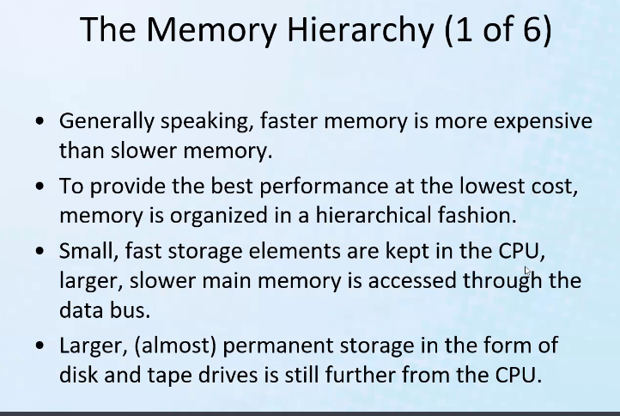
* Remember, bits are 1s and 0s and represents high and low voltage; this is how memory is written to and read from and also how these bits travel on a wire (as low and high voltages, 0s and 1s respectively)
* Remember electron velocity based on the resistance of a wire, which is based on the diameter of the wire and the length of the wire; thus further from CPU means you need a longer wire
  + Thus access time increases as a function of distance away from CPU
* 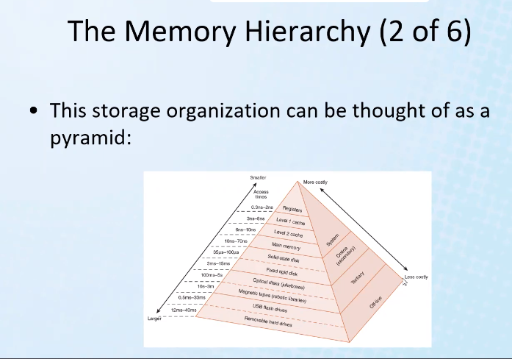
* Also it is more efficient to mix up the amount of memory and use the memory hierarchy in order to be more economical and efficient; many times for many applications if you used as much expensive (but faster) memory for the entire computer memory, then it could go to waste depending on if a user or application does/cannot handle enough data and executions to warrant such a level of memory. Some things can be done so fast it would be impossible to use a certain level of speed in processing power/memory access; also some tasks simply cannot be made faster by simply using faster memory – it could be a result of some other factors, so there again we could end up wasting a lot of valuable faster memory and paying unnecessary amounts of money
  + Thus, it is good to mix it up and be more efficient
* 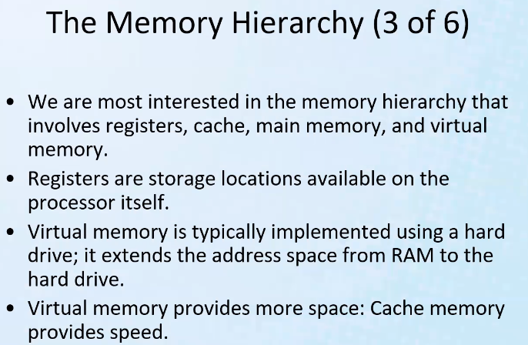
* Remember, the disk memory can be used as virtual RAM memory so as to expand the memory capabilities, but of course using the slower disk space as RAM memory won’t overcome the slower speeds that you will have to deal with for disk space; this is why it is simply called virtual memory
* This is also why when you disk space gets full, the computer performance can also suffer and slow down significantly because the disk space does not have as much free space for virtual RAM memory use; thus running certain apps or several apps like you might have been able to do before without problems may suddenly begin to suffer in its performance/ability to run smooth and fast
* 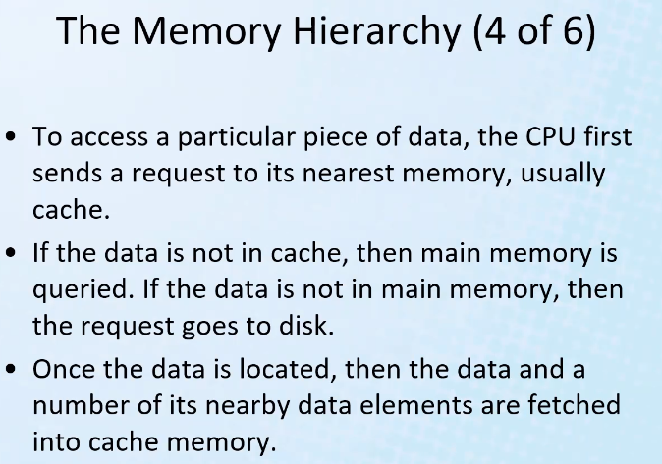
* When data requested is not in the cache, it is called a cache “miss”; maximizing cache “hits” is a key idea to consider when designing a computer architecture and writing programs
* Notice the hierarchical query structure that follows the hierarchical memory structure
* Also note: when cache misses (SRAM), and DRAM misses, then the virtual memory (extended DRAM address space that is expanded into the disk space) is queried
* Often if data is not in cache, then when data is found usually a block of that data is copied into cache; this algorithm is used to get more cache hits (it assumes that you will need some of the same data around the memory location just requested for access; so if an element from an array or loading a program is accessed, then potentially the entire array/program is copied into cache; thus the next access of an array or part of an array will give a higher probability of a cache hit!)
* So it is smart to make an algorithm to get potentially several related instructions from memory while you are there accessing the current requested memory location and put it into cache
* 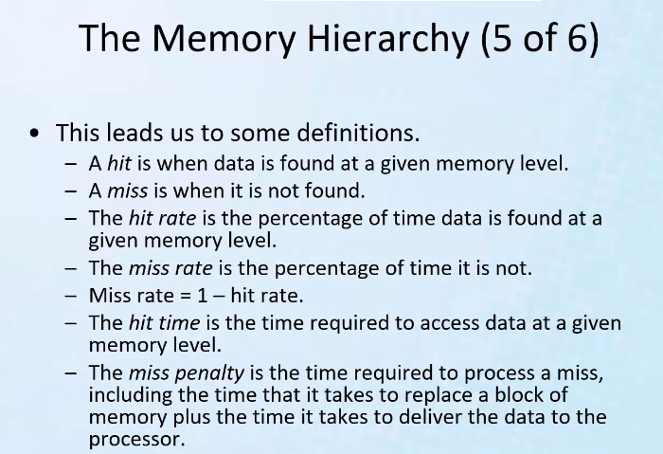
* Remember cache is used for copying an array of data from DRAM memory or virtual (disk) memory
  + For example, the CPU could put A0F0-A0FF (16 MEMORY locations (in a cache that can hold 16 memory locations) and the data stored at the locations are in the cache)
  + Thus when cpu requests a location within that range, it can simply check which block of addresses is in the cache (if it is there, boom we have a hit, if not then we have a miss)
* 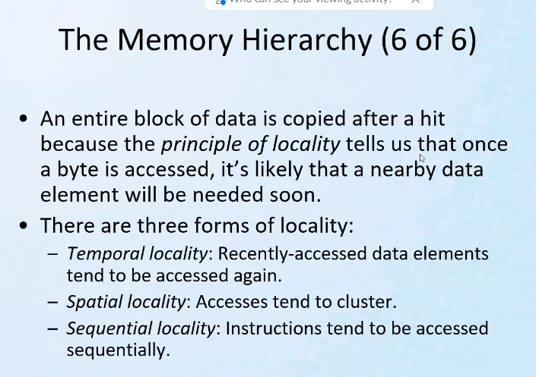
* Remember for efficiency (most of the time), data is often moved in blocks of memory
* Remember memory hierarchy and CPU design is often why we want to use arrays as often as possible; it is because you take advantage of the design architecture and algorithms for accessing memory
* 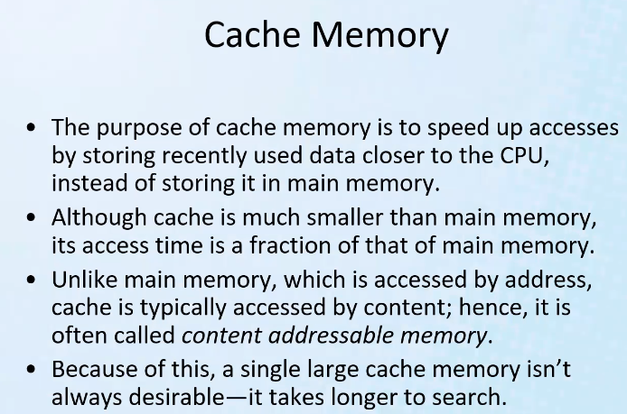
* Note for cache, we simply copy the contents of a block of memory locations; so we don’t actually use an address bus and have to wait on many clock cycles to access the memory; we simply say: cache is storing the contents of memory block A0F0 to A0FF for example; so the cache stores an array of data (a struct) containing the associated address of DRAM and the contents stored there (thus cache: = cam = content-addressable memory)
  + However, downside to cache is that it takes longer to search because it is CAM; this is why even though it gives faster access it is not always desirable for certain programs/algorithms; so it is good to have memory hierarchy and use the different memories not only for speed, but for other specialty purposes that give greater speeds for a given process (such as search).
  + So you can negate the effects of cache if you have too large of a cache because you will end up having to search all the content (search is slower for cache memory; but insignificant as long as cache is not too big)

# Lecture 6 – Memory Hierarchy part 2

* 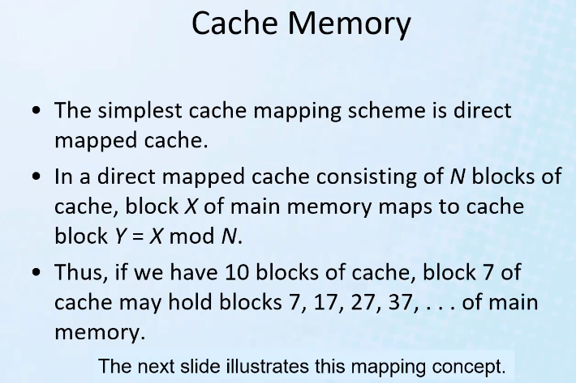
  + So here we get into the algorithm for which block/blocks of memory we will put inside caches when accessing non-cache memory so that we improve probability of a cache hit
* Remember CPU first checks cache memory when it needs data from a particular memory location
* Algorithms are designed such that the most probable information to be called on will be in the cache or the next fastest memory location
* 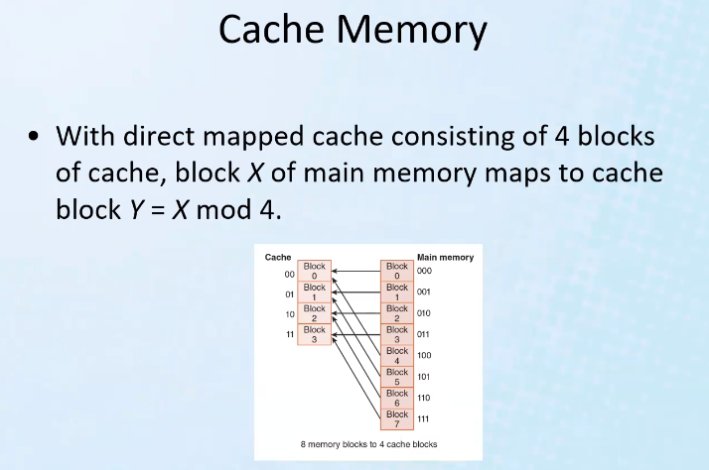
  + Notice cache is always smaller than main memory; otherwise it would defeat the purpose of memory hierarchy
  + Notice in the above example, each cache memory location block has 2 main memory locations mapped to it
* 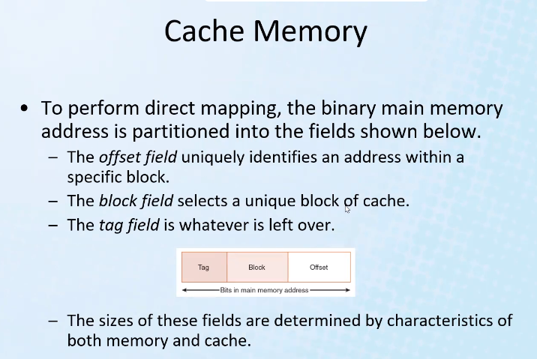
* Similar to masking with ip addressing
* 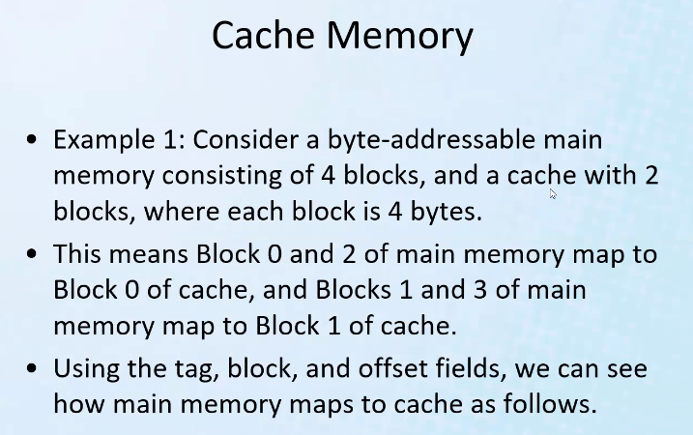
* 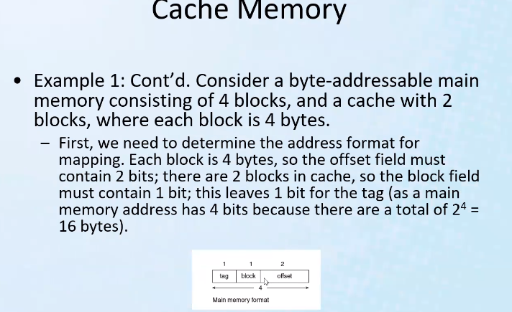
* 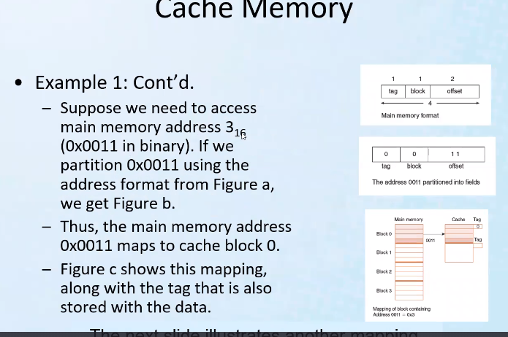
* So each main memory address can be partitioned so as to map to a specific block in cache, at a specific offset location in each cache block, with a given tag (tag tells if the information is the information that is desired; if it is then it will give a cache hit; if not, it is a cache miss)
* 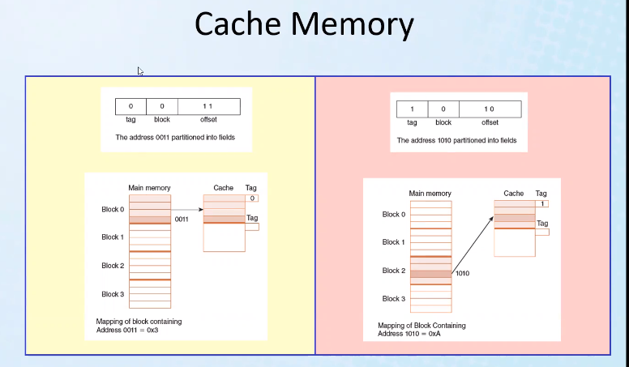
* Tag will tell which block of information is in the given cache location; remember multiple main memory blocks map to the same cache blocks
* 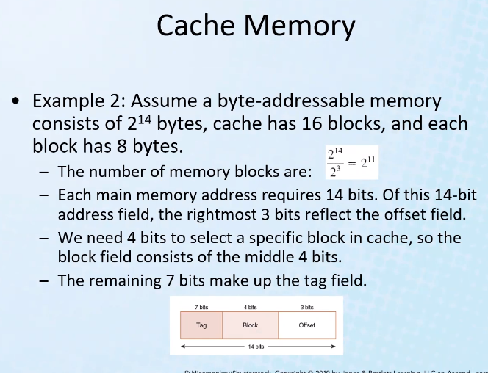
* Notice our job is made easier: 2^14 bytes already gives us how many bits we need to address the memory: 14 bits needed to address 2^14 bytes
* 16 = need 2^4 🡪 4 bits to address the cache blocks
* 2^3 = 8 = 3 bits needed to address each byte in each cache block
* Remaining 7 bits == tag field
* 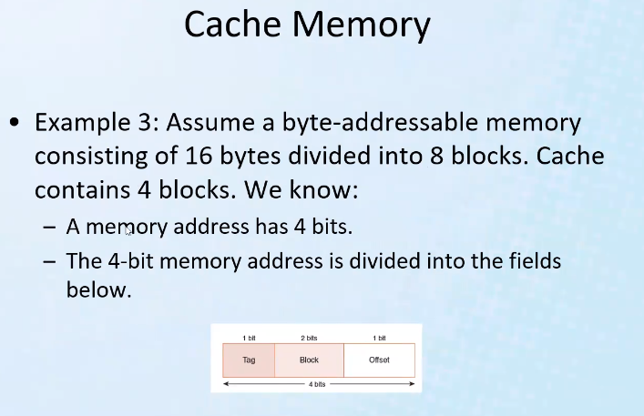
* 16/8 = each block contains 2 bytes
* 2 bytes = 2^1 = you only need 1 bit to get the offset in each block (to address each byte in each block)
* Remaining bits 4 -3 = 1 bit for the tag
* 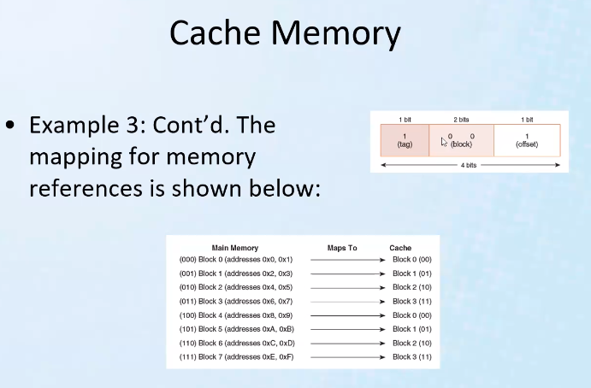
* This is the direct mapping scheme used by the CPU to place into and check cache blocks of main memory
* 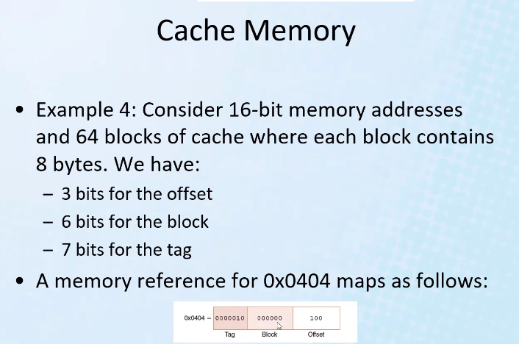
* 2^7 = 64; 7 bits used for block; 8 bytes in each block thus 2^3 = 8 = 3 bits for offset field
* Remaining bits = tag
* 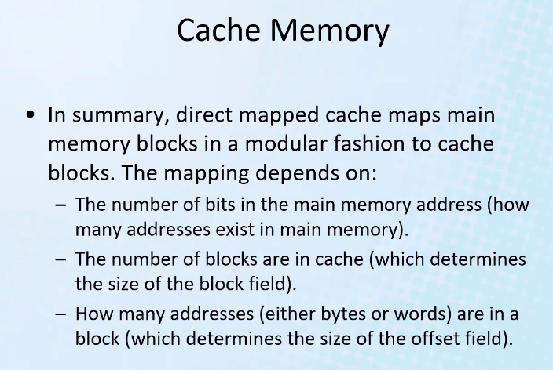
* Another cache mapping scheme: fully associative cache
* 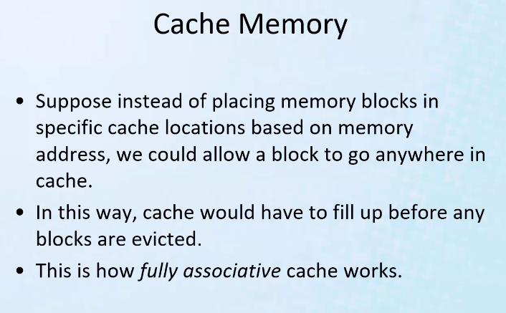
  + Disadvantage is you have to find a scheme to find information quickly in the cache since main memory can go anywhere in cache
* EAT: Effective Access Time
* 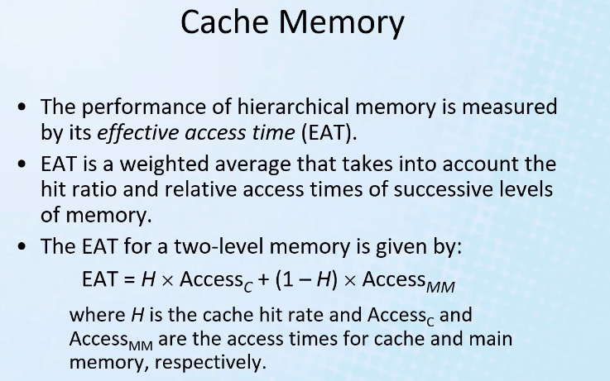
* 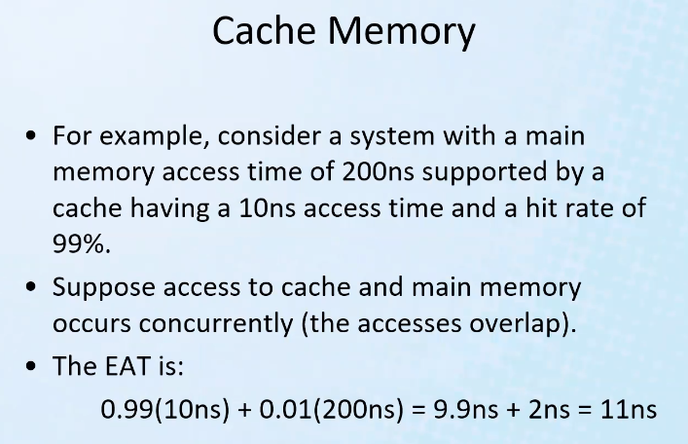
* This equation can be used in computer design or even custom building a computer; it can help you get the best speed and get the best price and most efficient use of a memory hierarchical structure
* If found in cache, then request concurrently sent to main memory will be ignored; but this is efficient because it will help reduce penalty time if we have a cache miss
  + Of course then this will use slightly more electricity
* Remember miss rate = 1- H 🡪(1 – hit rate)
* so overall (EAT) memory access speed is 11ns, and you didn’t have to spend a bunch of money on lots of cache
* 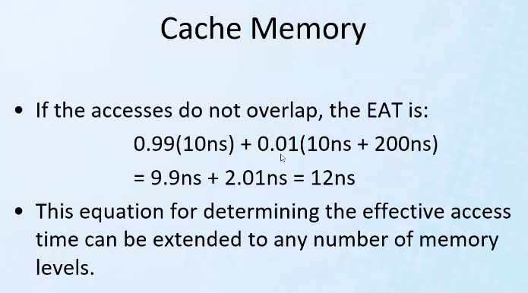
* Notice since not overlapping, then because cache miss means access time for main memory is effectively = 10+200 = 210ns
* Notice above this is a weighted average (multiply cache by H, and main by 1-H; where H is a rate out of 100)
* 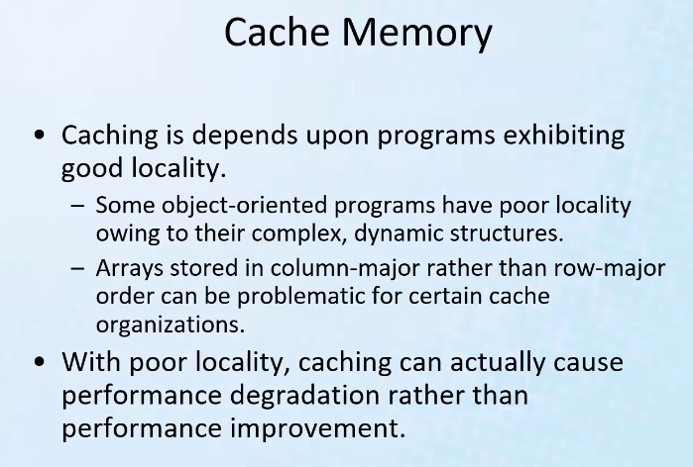
* This is why we make programs modular; because cache will read in bocks of memory, and will often guess that the next instruction will be nearby; so that’s why we avoid “spaghetti ball programming”
  + This is why we use dynamic binding
  + The pillars of OOP: encapsulation, inheritance, dynamic binding; we use these principles because of the array nature (contiguous memory) modular approach of programming, and this is how computer architecture most efficiently access memory using the cache and algorithms for storing memory in the faster cache memory
  + This is why caching can actually cause degraded performance if there is poor locality (arrays/contiguous modular approach to data storage of variables and functions)
* 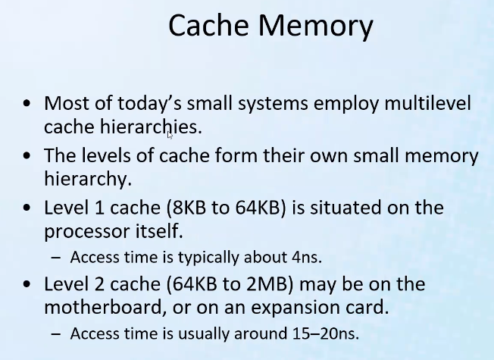
* 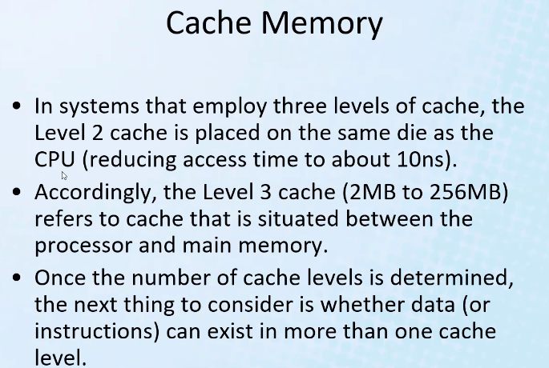
* Die = chip
* Notice even the memory hierarchy (levels) within the cache memory
  + Each level of cache is checked first, from fastest cache to slowest, of course incurring penalty each time there is a miss
  + The way for loading and checking cache levels of course consist of many algorithms to make the hierarchical structure work best and most efficient
* 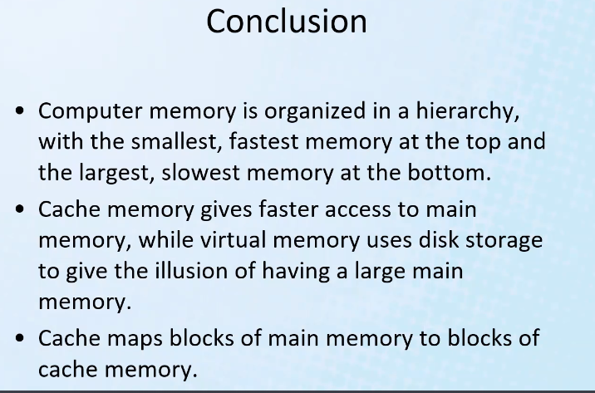
* Remember the memory is shared by the OS and other programs, so when a large program needs to be loaded, the virtual memory is memory extended to disk space so that CPU thinks there is more RAM memory than there is; but this is so that larger programs can still run without interfering with the real memory needed especially by the OS in order for the computer to run fast; but of course performance/runtime of the program loaded where some virtual memory is needed will be downgraded because of slower memory access

# Lecture 7 – Computer Organization: CISC vs RISC

* CISC: Complex Instruction Set Computer
  + Contains a large number of instructions
* Many instructions make it easier to translate from higher level to machine language; makes creating the compiler easier
* RISC: Reduced Instruction Set Computers
  + Less instructions in architecture design in order to improve execution speed
* CISC makes job of designing a computer architecture harder, while making the job of creating compilers for higher level language translation easier;
  + RISC on the other hand does the opposite: it makes the architect’s job in designing easier, but makes higher level language compiler design for translation much more difficult
  + Makes sense; more hardware instructions will make it closer to 1:1 translation than if you have less instructions in the instruction set; and of course less instructions means more code will be needed to achieve the same goal (you will have to combine more code of a smaller instruction set to the get the desired effect of another instruction; thus more instructions built into the design will cause you to have to write less code/use less instruction combinations since you have more instructions/more complex instructions already included in the design)
* RISC uses less memory access (and uses more CPU registers)
  + Restricts more operations to be done only in the CPU; and also reduces complexity of design of the circuit/computer architecture
* Remember: a compiler is just another program – it simply translate high level language statements into assembly language code
  + So with CISC, it is much easier to write such a compiler program
* RISC: mostly support reg to reg instructions
* Remember registers is fastest; then cache, then RAM, then disc space
* RISC: easier to decode since there are less instructions; and fixed length instructions only

# Lecture 8 – Computer Organization: Overview of Instruction Set Implementation

* Fundamental considerations for designing a processor/instructions set: 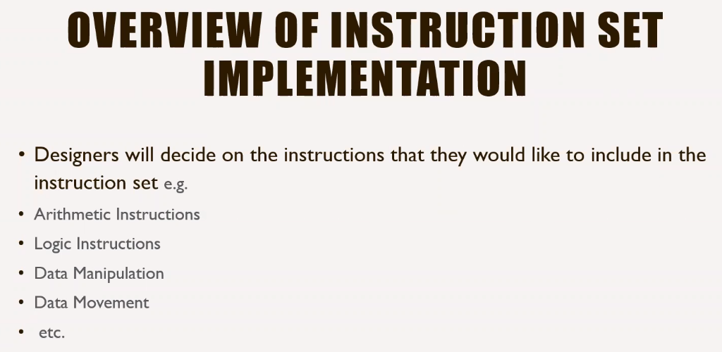
* When we design things, we should start with simple, basic elements, basic modules, then build from there: modular/elemental approach
* Remember reduced instruction set computers are easier to design and implement
* 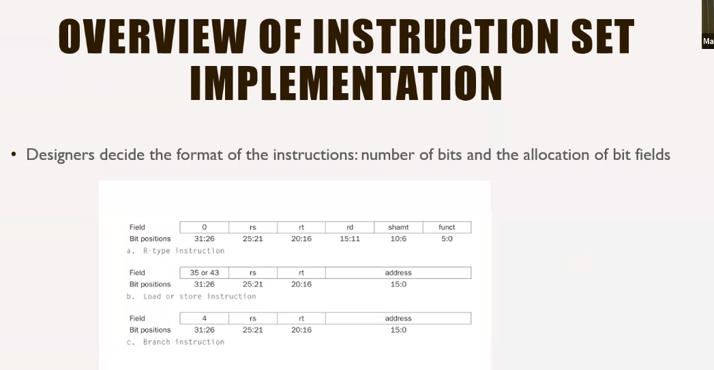
* Remember for RISC we keep instruction sizes the same size
  + Above shows an instruction set are all the same size
* R-type refer to ALU instructions
* 35 or 43 in above example refers to 6 bit value that represent load or store instruction
* So for the above RISC example, the first field refers to which type of instruction a given set of bits refers to
* Next step is to develop hardware that can implement the given designed instruction set:
* 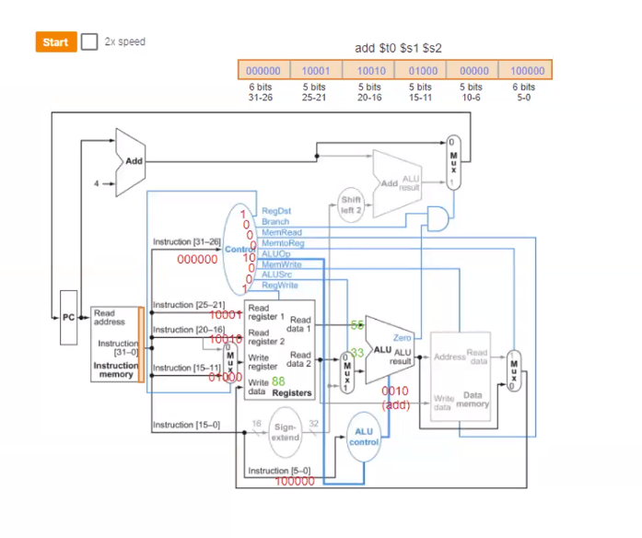
  + Instruction above refers to: add values in registers s1 and s2, and store them in t0
  + The first field (6 bit field, with all 0’s) tells microprocessor that it is receiving an arithmetic logic instruction
  + The last field tells which type of arithmetic logic instruction should be done (add)
  + The inner fields represent registers
  + You have to design a circuit to decode instructions
  + Notice above the entire instruction is 32 bits (bits 0 – 31), that is segmented into fields
  + The first field (instruction type) goes through the controller and produces the bit output shown; thick lines mean more than one bit (2 busses/wires), in this case 2 bits (10), and these busses go to the ALU controller; 2 bits mean there are 2^2 = 4 operations possible to send to the ALU to perform (10 == 0010 == add)
  + The 100000 is also a bit pattern needed to tell ALU to perform add operation
* Control logic:
* 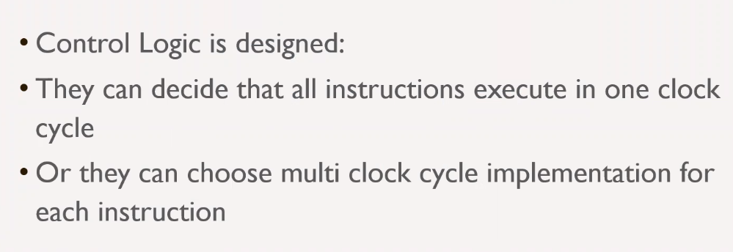
* Fetch, Decode, Execute all in one clock cycle is easy to design but not as efficient of a design
  + It is better to use smaller clock cycles rather than very large ones (although this is more complex to implement each Fetch, Decode, Execute instruction segments)
  + Smaller clock cycle will allow the CPU not to be occupied for so long and allow other parts of the CPU to be able to function/operate and not be idle
  + This will also allow for several instructions to be worked on together (pipeline), and this is especially important because some instructions depend on other instructions, so you don’t want to have a long clock cycle that does the entire F-D-E instructions in one clock; this will cause lots of idle time
* Easy method ALU instruction table (FDE all in one clock cycle):
* 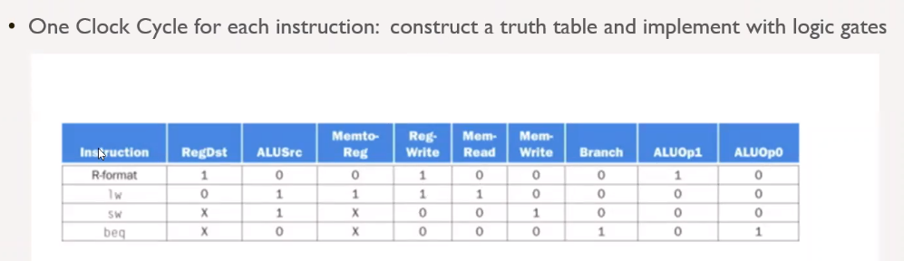
* R format == register format; for a given instruction you see a given output
* Lw and sw == load and store
* X means any value can go there – makes K map (canonical version == minimized version) easier to implement and more cost effective by reducing circuit
* Multi Clock cycles (more advanced, better performance: less idle time of all CPU components):
* 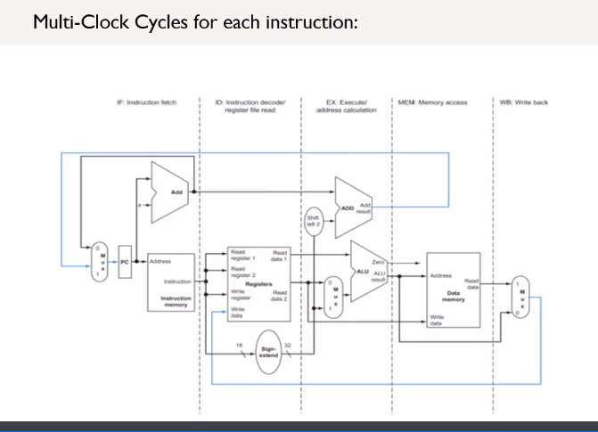
* Von Neumann model: divide the instruction into several phases (Fetch, Decode, Execute) that are separately completed in smaller and more frequent clock cycles
  + This allows for more memory access during the more frequent and shorter clock cycles
* Each phase can be done together for multiple different instructions in a given clock cycle
* Each instruction moves down the “pipeline” /CPU circuit, and new instruction phases can be added to the separate CPU components and completed during each clock cycle; hence reduced idle time of CPU
* 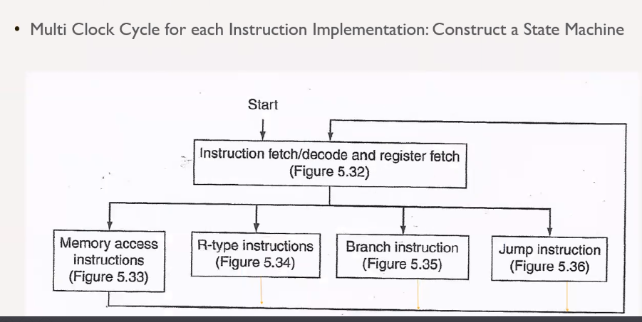
* Use a state machine in order to segment phases of instructions
* Each segment above shown in the state machine is a different component of the CPU that can be used separately
* 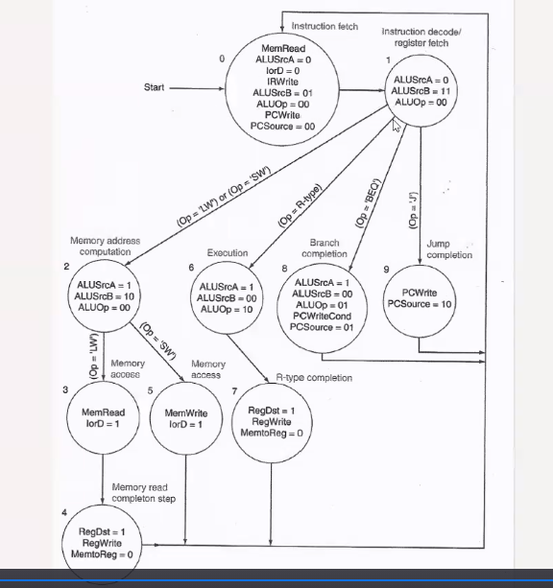
* The bits give the conditions for which branches to follow in the machine
* We are still implementing a RISC machine even though we are demonstrating a more complex but more efficient CPU instruction implementation
* 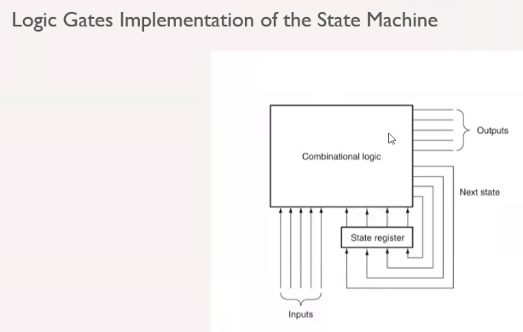
* Sequential logic will be for example the state register (remember JK flip flops)
  + Need inputs, and output of previous instruction (the history == state)
* 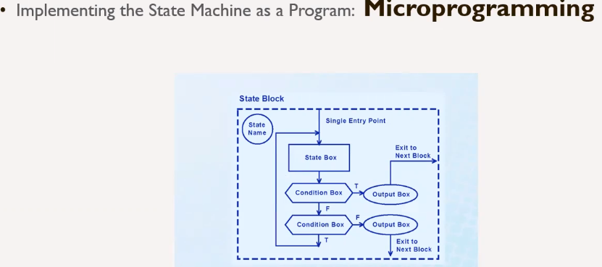
* Above shows how you can implement the controllers of the CPU as a program/State Machine
* Concept of microprogramming: using smaller CPUs/programming to build up a larger more complex CPU (concept of abstraction); you bring all the microprogramming/state machines together to get a very powerful, complex CPU/state machine/program
* See Mano book from this class in order to see more details on how to implement a CPU

# Lecture 9 – Alternative Architectures Part 1

* Fetch-Decode-Execute == Von Neumann classic computer architecture model that uses one processor and a memory hierarchy
* Modern processors do parallel computations using parallel multi-core processor architectures
  + Multithreading, load balancing, etc.
  + Break down instructions and send them to several processors to complete a task; similar to how information sent on a computer network can be broken down into packets and distributed among several intermediary devices and then rebuilt at its destination instead of being bottle-necked through one path and one set of intermediary devices
* Parallel and Multiprocessor architectures:
* 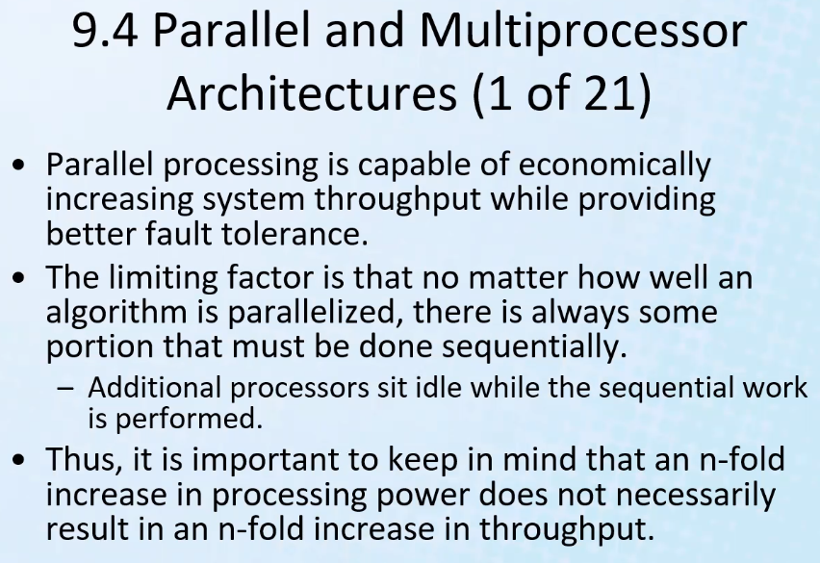
* Note: increasing RAM will help speed, but eventually more and more memory will is limited in speed improvements and will only improve capability of running more programs at once – not necessarily the speed at which those programs run; in order to truly get more computer speed you need to fundamentally/eventually improve the processor architecture (where calculations are done and memory manipulation is done fastest!) to improve raw speed of a computer (more memory and better/more efficient algorithms will still help tremendously of course!)
* If one thread (processor) needs the other, then parallel processing fails; it is only effective when tasks can be done independently of other tasks
* Fault tolerance == not depending on a single processor; can load balance and have backup processors
* Depending on the task: having more processors can improve speed of a program; but if the program requires mostly sequential, interdependent tasks then it may not help at all to have additional processors or may not be a 1:1 improvement depending on how many instructions in the program depend on each other
  + Example of when more processors has a direct improvement: controlling pixels on a screen; the more processors you have, the more instantaneous you can change the state of each pixel; these can all be done in parallel; so if you have 512 pixels, you could theoretically have 512 processors, one for each pixel, or instead of 1, use 2 processors; this will effectively cut the processing time in half; thus this example is an example of increasing processors by n-fold will directly improve processing time/power by n-fold for this particular task/program of changing pixel states.
  + Graphic and video cards (processors) specifically handle such tasks such as changing pixels on the screen: they heavily use parallel processing
* 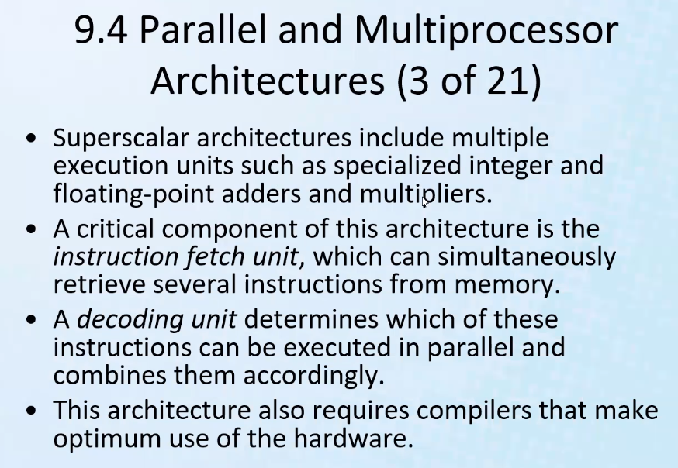
  + Superscalar architectures: multiple and specialized processors added to the computer architecture to handle specific tasks more efficiently
  + Each components above are separate processors that are themselves capable of doing parallel processing and work together to parallel process
  + When designing a compiler program, you need to know about these special co processors with their particular assembly language in the computer architecture
* 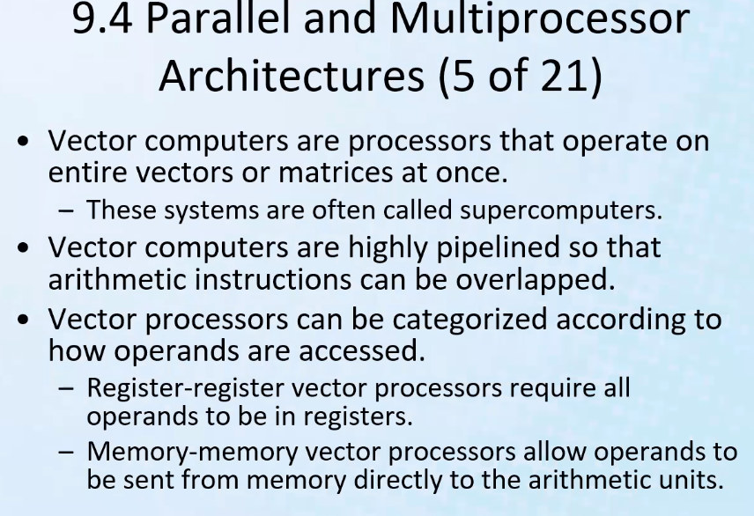
  + Think about array/matrix multiplication; this is what makes such a system a SUPER COMPUTER!
  + You wanna multiply matrices and take advantage of linear algebra in its fuller capacity?: you need a super computer architecture
* Remember if you run instructions the simple way in a single clock cycle; but the drawback is that the clock cycle has to be long enough to accommodate the longest instruction
* More efficient way: instructions take several clock cycles to complete the FDE cycle (pipelining/overlapping each Fetch Decode and Execute tasks separately for several instructions at once in order to reduce idle time of CPU components; have phases of execution for instructions by using the smaller clock; will increase CPU throughput)
* 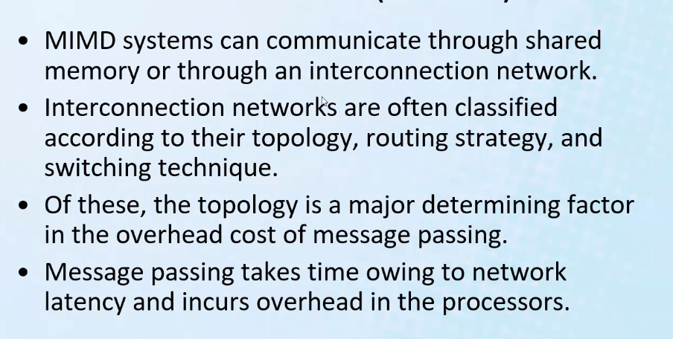
* MIMD == Multiple Inputs Multiple Data systems
  + Several processors are synchronized through shared memory and tell when they are not using the memory so that the other processors know that the memory is available for use
* Latency: how fast a message can go from one computer or processor to another
  + Based on net limitations of all components in the network
* 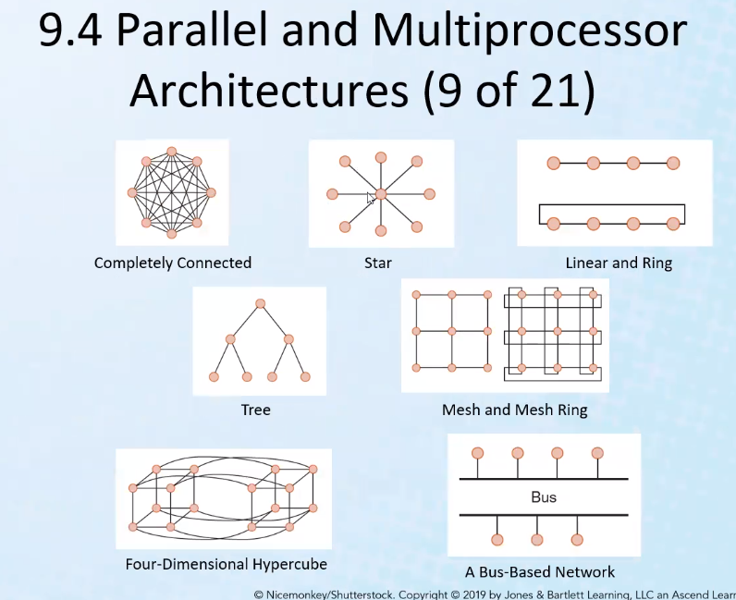
  + Similar concepts from CCNA networking certification
* 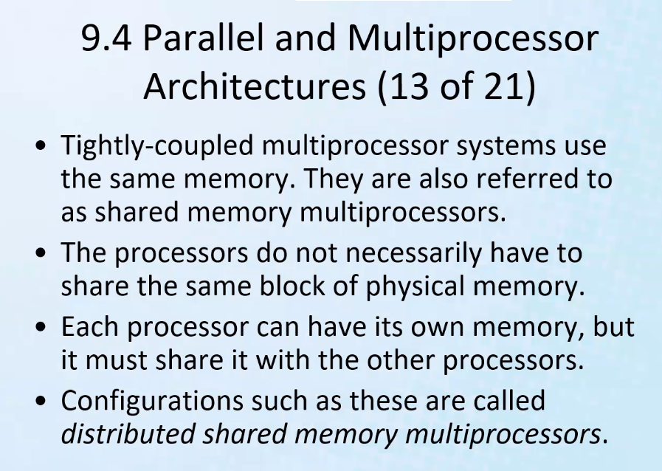
* Need to share memory in order to execute programs in parallel
* 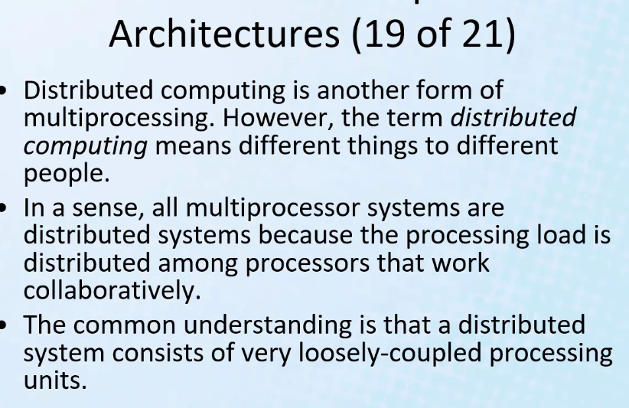
* All multiprocessor systems are distributed systems, but the reverse is not always true
* Distributed computing is conventionally with regards to network processing
  + But for processors, they are usually tightly coupled
* 
* Cloud computing example: using shared document on google docs and collaborating in real time with other users who are simultaneously or at a later time editing the document (the same memory; thus memory is shared)

# Lecture 10 – Alternative Architectures Part 2

* Alternative Parallel Processing Approaches
* 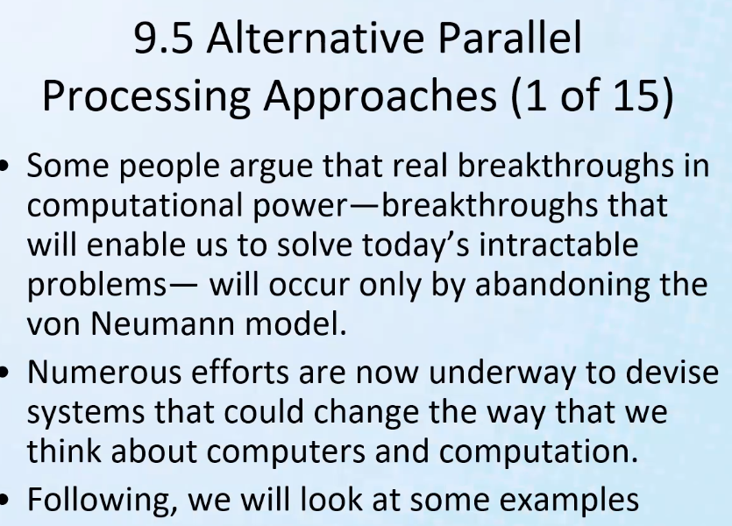
* Physics will eventually not allow us to keep packing more and more circuits onto a microprocessor to make it more powerful – there is a limit that we are approaching and will eventually hit
  + This is the drive for trying to develop more/better parallel architectures
* 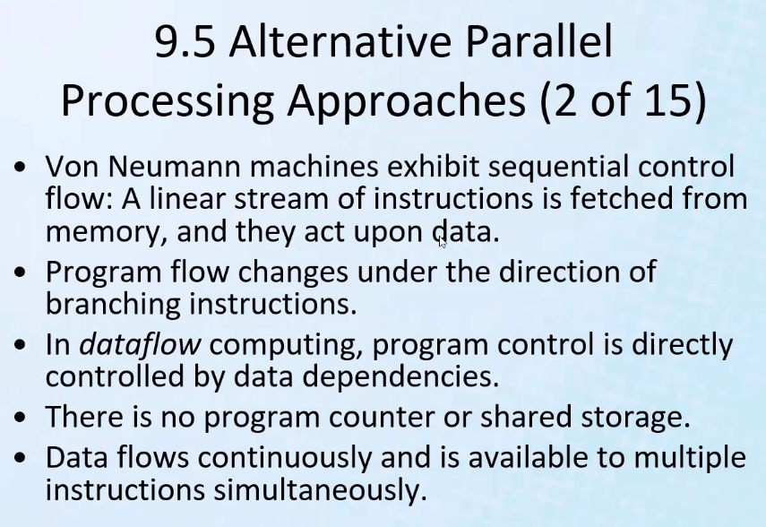
  + Newer approaches allow multiple instructions to be fetched and decoded at same time, and some instructions can be solved in parallel, but still some instructions depend on others and need to be solved sequentially.
* Data flow computing is related to neural computing
  + Similar to how our brains function
* 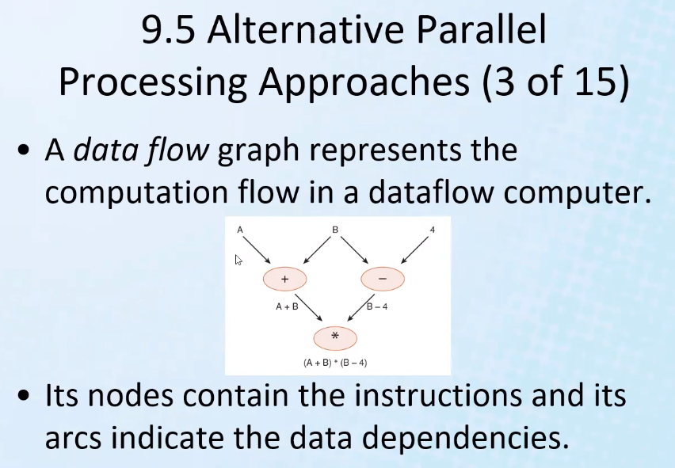
  + Computation does not happen under direction of a clock – there is no clock; each node in the above graphic representation could be thought of as its own processor where data is available to all nodes simultaneously to be processed by each node.
* 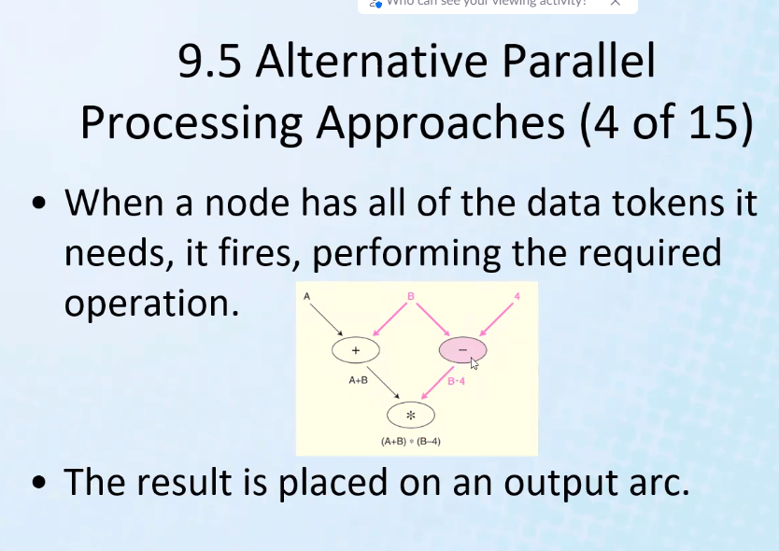
* 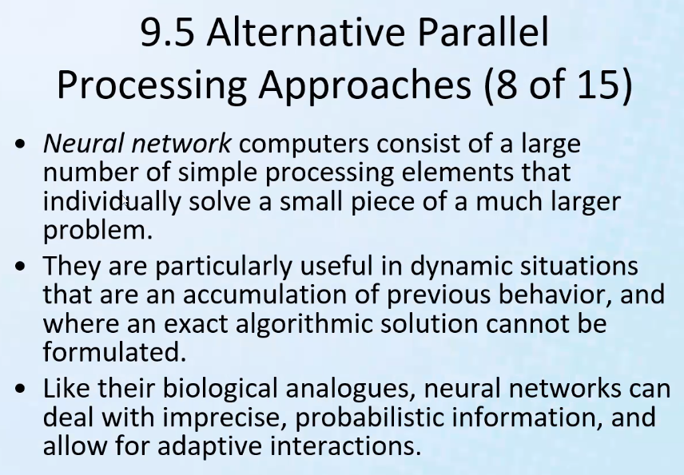
  + Think of CIS-350: dynamic programming (Fibonacci) or think of divide and conquer approach to solving problems with programming; although we use these approaches to find a solution, a lot of the programming we do is still sequentially implementing the above approaches
  + Being able to implement the above solution approaches using parallel/neural network computers would make for extremely powerful computers since each of those individual solutions or part of those solutions could be obtained simultaneously – computers would become exponentially faster!
  + We theorize that the brain processes in parallel and without a clock
  + Neural network computers are those that are used for very powerful surveillance technology (facial recognition, tracking, etc.) that uses a special cloud database where information/data is available to every processing unit at the same time. Same type of technology is used for self-driving cars, and similar technology
  + Utilizing concepts of “deep learning”
* Before he died, the last computation architecture that Vonn Neumann himself was researching was neural networks – which his wife published after his death by his wife
* 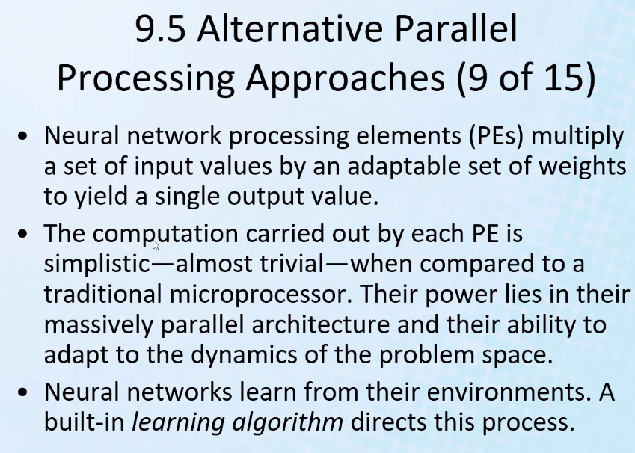
* 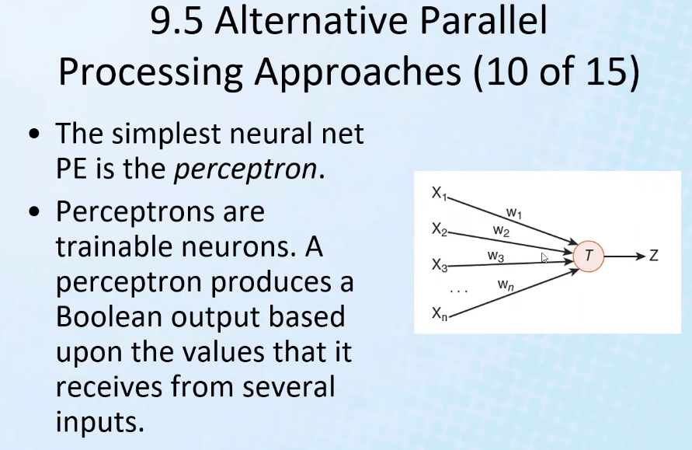
  + Perceptron is one of the first incarnations or implementations of a neural network
* 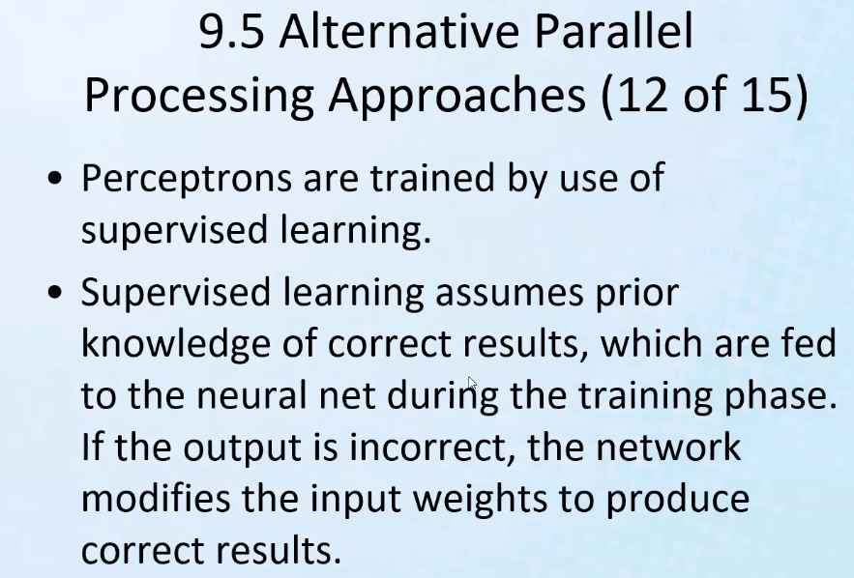
* Supervised learning: expose to some input, and teach it the answer (correct output)
  + So that next time it can give answer without you telling it
* Quantum Computing
* 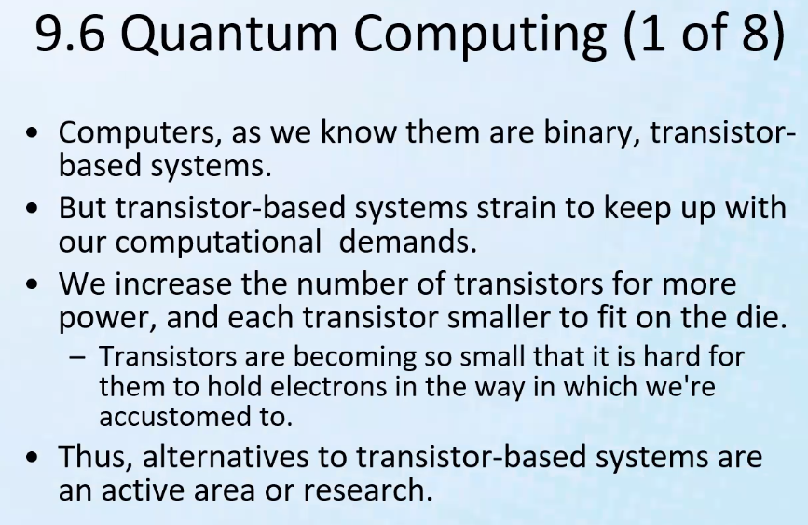
* Even using binary can be compared to dynamic programming and divide and conquer approaches since on-off (high-low) signals are combined together to translate values and solve problems – of course it takes millions of them (the patterns, etc)
* If you can develop a circuit with a faster switch, then you can process more (that is why we have microprocessors and they kept getting smaller to improve switch speed and packing more circuits onto it; it also improved switch speed, but as we mentioned before, there is a physical limitation to using this approach to improve processing speed/power)
* We use pipelining in Van Neuman architecture to simulate using parallelism because some problems naturally flow better by using parallel methods; quantum computing allows for the ability to use more parallel abilities in computation
* 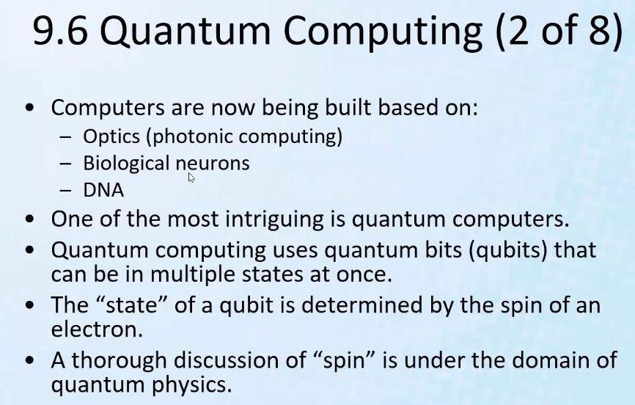
  + Think: normal bits can only be in 2 states, but only in one of those states at a time – on or off (high or low voltage in the transistor)
  + If a qubit can be in multiple states at once, then it can be used to represent multiple values at the same time so that multiple processors can work potentially on the same data (one qubit can be used for several inputs) – or such that qubits can represent more than just 2 states thus they may use a different number system (instead of base 2, some higher base for example base 4).
* Each electron in an atom is described by **four different quantum numbers**. The first three (n, l, ml) specify the particular orbital of interest, and the fourth (ms) specifies how many electrons can occupy that orbital.
  + 1. Principal Quantum Number (n)
  + 2. Angular Momentum (Secondary, Azimunthal) Quantum Number (l)
  + 3. Magnetic Quantum Number (ml)
  + 4. Spin Quantum Number (ms)
* 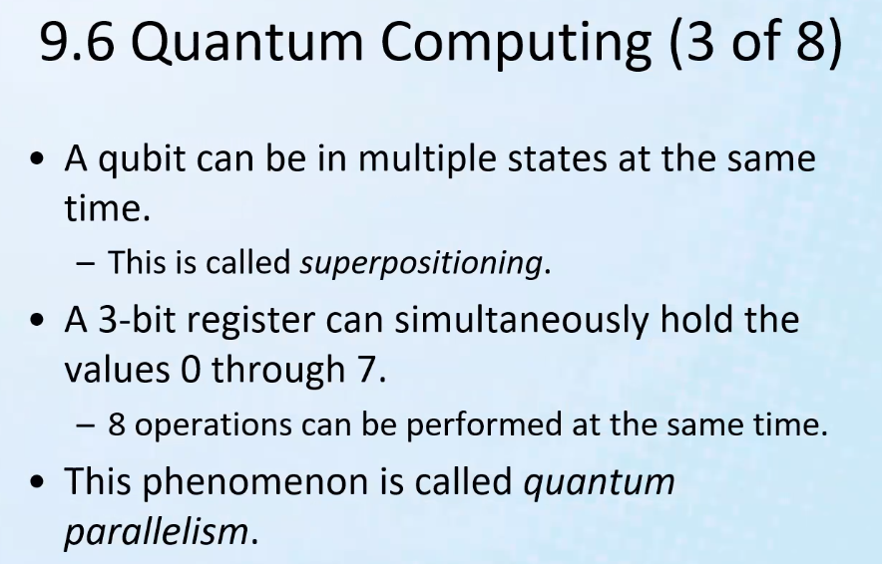
* Since qubits can be several states at the same time, then if you look/perceive the qubits from a different “angle”/perspective, then you can see the other values that it is storing simultaneously; you can select which perspective based on the problem to look at the qubits and then use it for input
  + Since multiple states occur at same time, then several processors can look at the same qubits from different perspectives and work on the data/input they receive and start to solve a problem
* 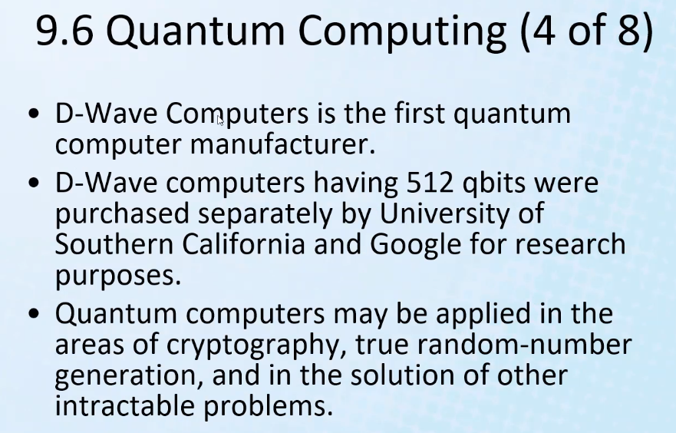
* Cryptography of course refers to encryption
* Simulating nuclear reactions is intensive for computers – of course simulation software in general has always been a challenge for computers as it completely uses the computer architecture to its maximum capacity
* 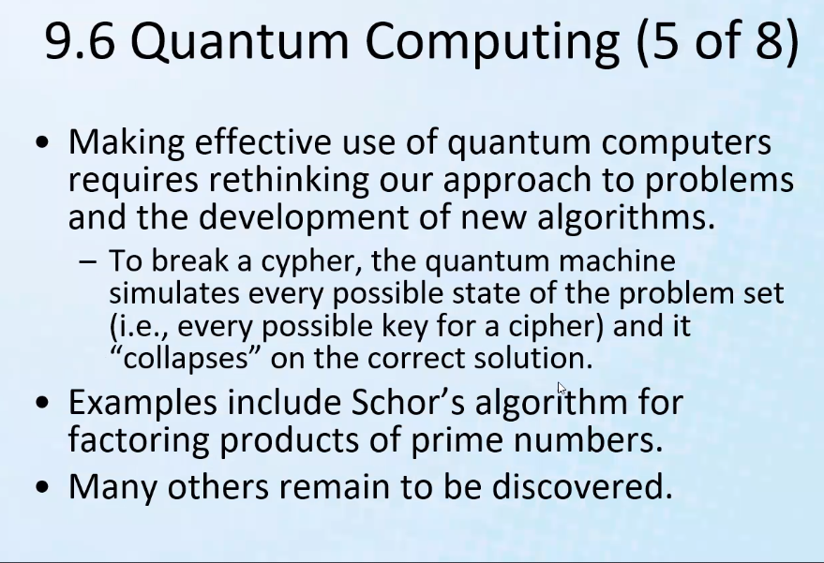
* Notice: because quantum computers are powerful enough to look at what was previously an infeasible number of combinations to search to arrive at the solution, we would need new approaches to encryption since old encryption would actually be able to decrypted in a sufficient amount of time to be useful or solved at all by quantum computers (even some super computers cannot decrypt fast enough or at all).
* So quantum computers will allow very strong current encryption standards to be broken, but/and will allow/need for even stronger encryption methods
* 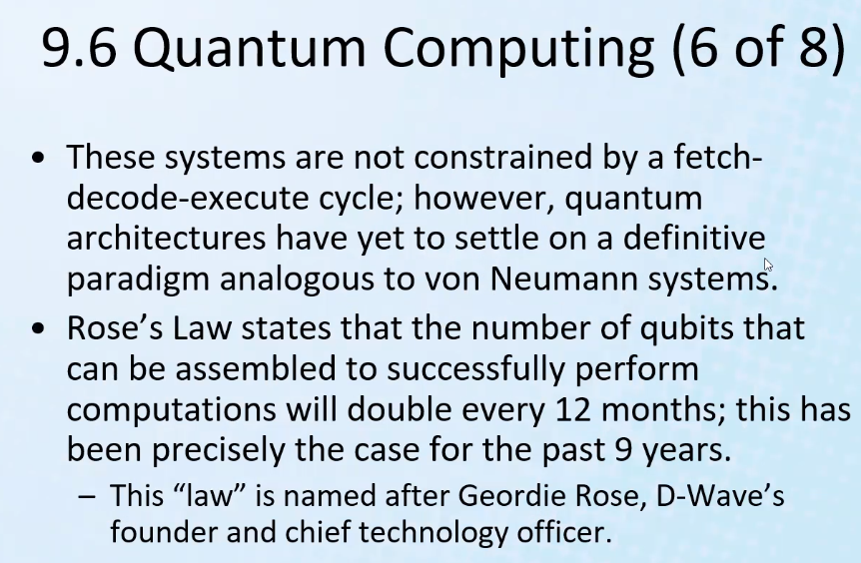
* Every 12 months, quantum computers can support double the number of qubits
* 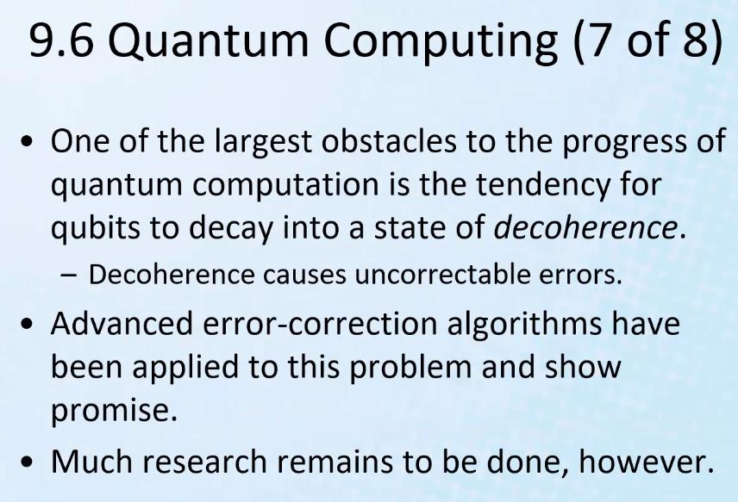
* Method to freeze the states would require freezing the atoms at a very low temperature which is infeasible; so decoherence is a big issue
* So, it looks like standard Van Neuman model will always be useful and especially taking advantage of electricity
* 
* But there is one point they are not considering: God made the human brain a machine of superior abstraction capabilities; we do not need to know the details of lower levels to master, conquer, or overcome anything; computers will never be able to develop their own standards and layers of abstraction on their own
* 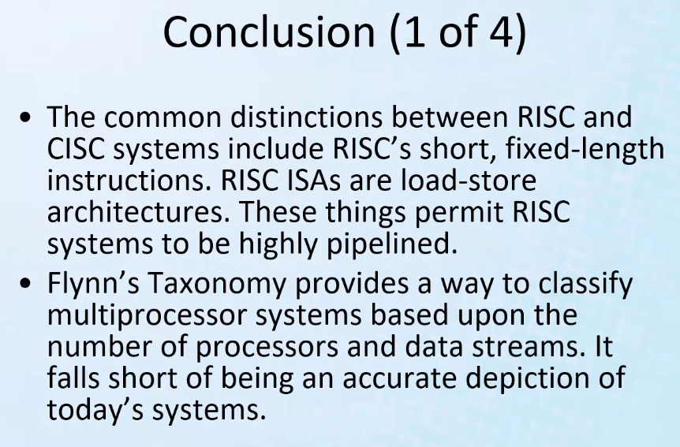
* Remember risk fixed-length instructions aspect; pipelining improves throughput on the CPU
* 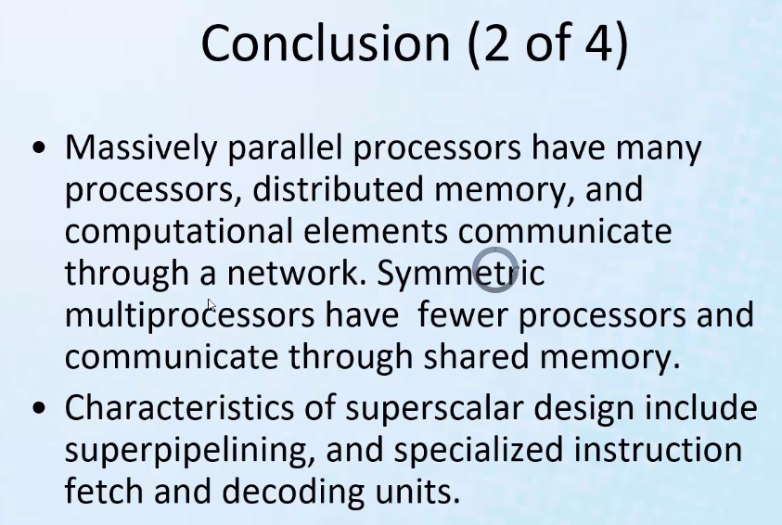
* 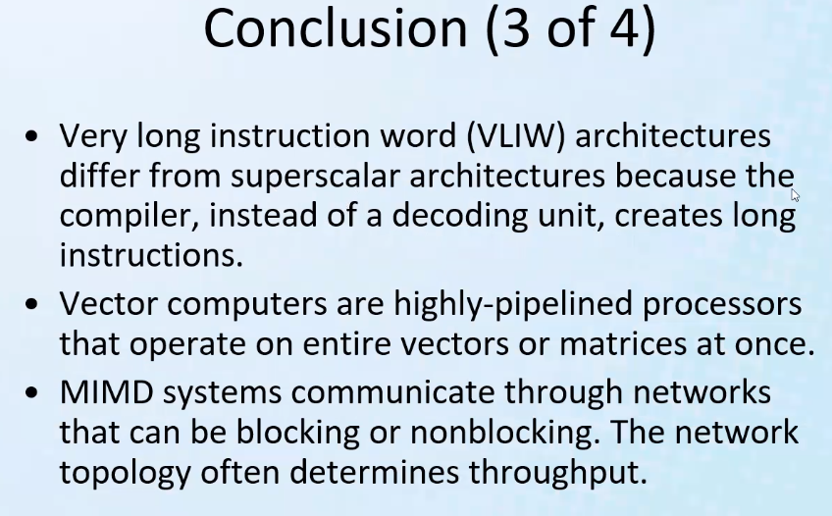
* VLIW 🡪 Using the intelligence of the compiler to work with computer architecture to speed up processing by the way it breaks down instructions to the hardware language
* Remember vector computers and super scalar designs are used in supercomputer architectures
* MIMD == Multiple Instructions Multiple Data
  + Multiple CPU’s connected on a internet network to work together to make a computation (think cloud based computing)
* 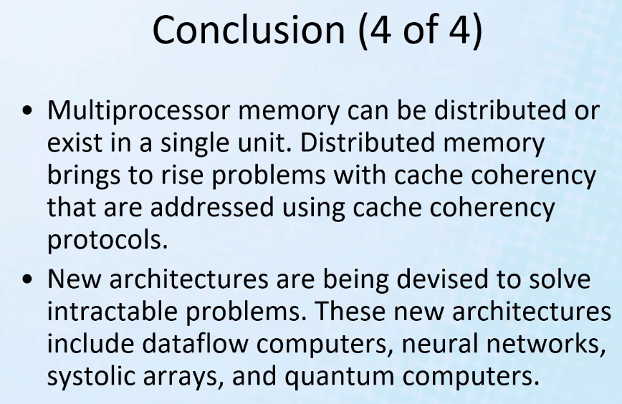
* How would updated cache be reflected on other nodes?
  + A prediction algorithm has to be used for how to calculate the cache if you cannot populate the cache or have redundancy or if one update is negated by another processor that is working in parallel using the same distributed memory